Our Lady’s Catholic College

PE Assessment overviews
Our Lady’s Catholic College, Morecambe road, Lancaster, La12rx

PE Department assessment overview
Rationale
KS3
The PE department uses both formative and summative assessments to inform both staff and students of the progress made and the areas for future development. The component knowledge of each curriculum area is assessed using Multiple Inadequate Glances (MIG’s) to formally assess the students’ knowledge and understanding and to allow for responsive teaching before progressing through the curriculum. Pupils are assessed in one of four ways in KS3 (the pillars of PE). The development of techniques vital to sporting success, the ability to apply appropriate tactics and strategies to outwit opponents, the ability to analyse the performance of others and themselves to identify areas of improvement and their knowledge and understanding of how physical activity and sport contribute to physical, mental and social wellbeing. Each MIG takes place following the scheme of learning has been delivered with formative assessment taking place throughout.
Assessment in PE focusses on the pillars of PE rather than individual sports, allowing pupils to develop an understanding of how learning skills and the key concepts of different types of activities can be transferred. MIG’s are tracked on a half-termly basis and form the basis of future learning and development of the curriculum.
Summative assessments take place in line with the whole school assessment calendar and allow the PE department to take a broader view of pupil’s progress across a number of curriculum areas.
KS4 & KS5
In GCSE PE a variety of assessment activities are used for MIGs. Low stakes quizzes, lesson retrieval activities, past paper questions as well as STA marked tasks in line with the school assessment policy and practical assessments. Tasks build in complexity replicating the organization of the AQA question structure with students developing their ability to respond to AQA’s A01, A02 and A03 answers. Where possible past paper questions are used so that mark schemes can be utilised to ensure consistency of marking. End of Unit Tests assess the understanding of each topic area whilst tracking information is collected on a spreadsheet to allow reviewing of student progress across a number of topics and also to compare performance between topics so that teaching can be reviewed. The spreadsheet replicates the exam board overall breakdown so that aspects of underperformance can be highlighted quickly and interventions put into place.
A level PE assessment follows the same pattern as the GCSE assessment model above.

KS3 Year 7
Year 7 Boys PE |  | Year 7 Girls PE
Half Term 1 | Rugby  MIG 1: Developing techniques, passing and receiving  MIG 2: Tactics & strategies, Scanning  OR  Netball  MIG 1 developing techniques, passing and receiving  MIG 2 Tactics & strategies, Scanning | Half Term 1 | Rugby  MIG 1: Developing techniques, passing and receiving  MIG 2: Tactics & strategies, Scanning  OR  Netball  MIG 1: Developing techniques, passing and receiving  MIG 2: Tactics & strategies, Scanning
Half Term 2 | Gymnastics  MIG 3: Developing techniques, Rolls and balances  MIG 4: Analysis of performance – peer analysis and suggested improvements  Football  MIG 3: Developing techniques, passing and receiving  MIG 4: Tactics & strategies, scanning | Half Term 2 | Gymnastics  MIG 3: Developing techniques, rolls and balances  MIG 4: Analysis of performance, peer analysis and suggested improvements  OR  Football  MIG 3: Developing techniques, passing and receiving  MIG 4 Tactics & strategies, scanning
Half Term 3 | Handball  MIG 5: Developing techniques, shooting and attacking  MIG 6: Tactics & strategies | Half Term 3 | Dance  MIG 5: developing techniques demonstrate dance skills (Rhythm and timing)  MIG 6: Analysis of performance - peer analysis and suggested improvements
Half Term 4 | Dance  MIG 7: Developing techniques demonstrate dance skills (Rhythm and timing)  MIG 8: Analysis of performance - peer analysis and suggested improvements | Half Term 4 | Handball  MIG 7: Developing techniques, shooting and attacking  MIG 8: Tactics & strategies
Half Term 5 | Athletics  MIG 9: developing techniques, running technique  MIG 10: Analysis of performance – peer analysis and suggested improvements | Half Term 5 | Athletics  MIG 9 developing techniques, running technique  MIG 10: Analysis of performance – peer analysis and suggested improvements
Half Term 6 | Cricket  MIG 11: developing techniques, throwing/catching & fielding  MIG 12: Tactics & strategies, decision making and application of tactics  OR  Rounders  MIG 11: developing techniques, throwing/catching & fielding  MIG 12: Tactics & strategies, decision making and application of tactics | Half Term 6 | Cricket  MIG 11: developing techniques, throwing/catching & fielding  MIG 12: Tactics & strategies, decision making and application of tactics  OR  Rounders  MIG 11: developing techniques, throwing/catching & fielding  MIG 12: Tactics & strategies, decision making and application of tactics

KS3 Year 8
Year 8 Boys PE |  | Year 8 Girls PE
Half Term 1 | Rugby  MIG 1: Developing techniques, passing and receiving  MIG 2: Tactics & strategies, movement in space  OR  Netball  MIG 1: developing techniques, passing and receiving  MIG 2: Tactics & strategies, movement in space | Half Term 1 | Rugby  MIG 1: Developing techniques, passing and receiving  MIG 2: Tactics & strategies, movement in space  OR  Netball  MIG 1: developing techniques, passing and receiving  MIG 2: Tactics & strategies, movement in space
Half Term 2 | Gymnastics  MIG 3: developing techniques, counter balance and tension partner work  MIG 4: Analysis of performance, peer analysis and suggested improvements  OR  Football  MIG 3: Developing techniques, creating space  MIG 4: Tactics & strategies, movement in space | Half Term 2 | Gymnastics  MIG 3: Developing techniques, counter balance and tension partner work  MIG 4: Analysis of performance, peer analysis and suggested improvements  OR  Football  MIG 3: Developing techniques, creating space  MIG 4: Tactics & strategies, movement in space
Half Term 3 | Handball  MIG 5 developing techniques, shooting and attacking  MIG 6 Tactics & strategies, movement in space  OR  Dance  MIG 5 developing techniques – characterisation  MIG 6: Analysis of performance, peer analysis and suggested improvements | Half Term 3 | Handball  MIG 5: Developing techniques, shooting and attacking  MIG 6: Tactics & strategies, movement in space  OR  Dance  MIG 5: Developing techniques - characterisation  MIG 6: Analysis of performance, peer analysis and suggested improvements
Half Term 4 | Health for Life  MIG 7 and 8: Health & wellbeing (physical and mental wellbeing) | Half Term 4 | Health for Life  MIG 7 and 8: Health & wellbeing (physical and mental wellbeing)
Half Term 5 | Athletics  MIG 9: Developing techniques  Jumping technique high jump/long jump  MIG 10: Analysis of performance, self-analysis and suggested improvements | Half Term 5 | Athletics  MIG 9: Developing techniques  Jumping technique high jump/long jump  MIG 10: Analysis of performance, self-analysis and suggested improvements
Half Term 6 | Cricket  MIG 10: developing techniques, batting  MIG 11: Tactics & strategies, decision making and application of tactics  OR  Rounders  MIG 10: developing techniques, batting  MIG 11: Tactics & strategies, decision making and application of tactics | Half Term 6 | Cricket  MIG 10: developing techniques, batting  MIG 11: Tactics & strategies, decision making and application of tactics  OR  Rounders  MIG 10: developing techniques, batting  MIG 11: Tactics & strategies, decision making and application of tactics

KS3 Year 9
Year 9 Boys PE |  | Year 9 Girls PE
Half Term 1 | Rugby  MIG 1: Developing techniques, tackling  MIG 2: Tactics & strategies, deception  OR  Netball  MIG 1: Developing techniques, movement intercepting  MIG 2: Tactics & strategies, deception | Half Term 1 | Rugby  MIG 1: Developing techniques, tackling  MIG 2: Tactics & strategies, deception  OR  Netball  MIG 1: Developing techniques, movement intercepting  MIG 2: Tactics & strategies, deception
Half Term 2 | Gymnastics  MIG 3: Developing techniques demonstrate flight  MIG 4: Analysis of performance, self-analysis and suggested improvements  OR  Football  MIG 3: Developing techniques, Intercepting and tackling  MIG 4: Tactics & strategies, deception | Half Term 2 | Gymnastics  MIG 3: Developing techniques demonstrate flight  MIG 4: Analysis of performance, self-analysis and suggested improvements  OR  Football  MIG 3: Developing techniques, Intercepting and tackling  MIG 4: Tactics & strategies, deception
Half Term 3 | Handball  MIG 5: Developing techniques, penetrating the D shooting and attacking  MIG 6: Tactics & strategies, deception  OR  Dance  MIG 5: Developing techniques  MIG 6: Analysis of performance, self-analysis and suggested improvements | Half Term 3 | Handball  MIG 5: Developing techniques, penetrating the D shooting and attacking  MIG 6: Tactics & strategies, deception  OR  Dance  MIG 5: Developing techniques  MIG 6: Analysis of performance, self-analysis and suggested improvements
Half Term 4 | Health for Life  MIG 7 and 8: Health & wellbeing (physical, mental and social wellbeing) | Half Term 4 | Health for Life  MIG 7 and 8: Health & wellbeing (physical, mental and social wellbeing)
Half Term 5 | Athletics  MIG 9: Developing techniques, throws  MIG 10: Analysis of performance, self-analysis and suggested improvements | Half Term 5 | Athletics  MIG 9: Developing techniques, throws  MIG 10: Analysis of performance, self-analysis and suggested improvements
Half Term 6 | Cricket  MIG 11: Developing techniques, bowling  MIG 12: Tactics & strategies, decision making and application of tactics  OR  Rounders  MIG 11: Developing techniques, bowling  MIG 12: Tactics & strategies, decision making and application of tactics | Half Term 6 | Cricket  MIG 11: Developing techniques, bowling  MIG 12: Tactics & strategies, decision making and application of tactics  OR  Rounders  MIG 11: Developing techniques, bowling  MIG 12: Tactics & strategies, decision making and application of tactics

Year 10 GCSE
1 | End of unit test Skeleton
2 | End of unit test muscles
3 | End of unit test cardiovascular system
4 | Quality marked work 1 Movement
5 | End of unit test respiratory system
6 | Building up a long answer response
7 | End of unit test components of fitness
8 | Quality marked work 2 COF strength
9 | AQA summative assessment anatomy and phys
10 | End of unit test fitness tests
11 | Quality marked work 3 COF weakness
12 | End of unit test principals and types of training
13 | Quality marked work 4 (9 mark questions)
14 | End of unit test short and long term effects
15 | Quality marked work 5 Skill weakness
16 | End of unit test leavers planes axis
17 | AQA summary exam summer Mock
18 | Coursework review
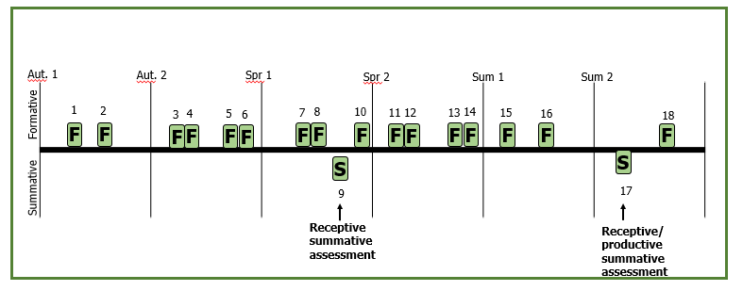

Year 11 GCSE
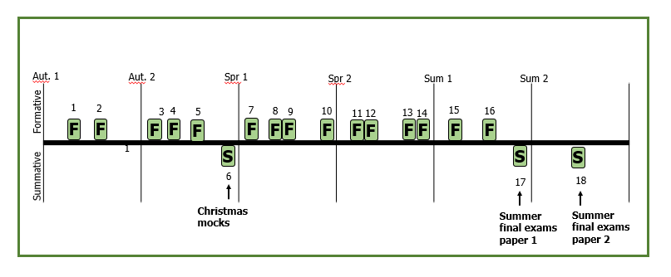
1 | End of unit test targets, goals and classifications of skill
2 | End of unit test guidance and info processing and Arousal
3 | Coursework deadline 1
4 | End of unit test motivation, aggression and personality types
5 | Building up a long answer response
6 | Christmas mocks
7 | Coursework final deadline and final mark
8 | End of unit test engagement patterns
9 | End of unit test obesity and somatotypes and nutrition
10 | End of unit test PED’s, etiquette and Hooliganism
11 | Quality marked work (9 mark question tech)
12 | End of unit test commercialization
13 | End of unit test Technology
14 | Quality marked work 9 mark questions
15 | Past paper questions
16 | Past paper questions
17 | AQA exam summer paper 1
18 | AQA exam summer paper 2

Year 12 A Level PE

1 | End of unit test – Musculoskeletal system and movement analysis (F)
2 | End of unit test – Diet, nutrition and supplements (F)
3 | End of unit test – Neuromuscular system (F)
4 | End of unit test – Training methods, principles and data (F)
5 | End of unit test – Respiratory system (F)
6 | End of unit test – Injury prevention and rehabilitation (F)
7 | Quality marked work 1 – Cardiovascular responses and regulation (S)
8 | End of unit test – Personality, attitudes, arousal, anxiety, aggression and motivation (F)
9 | End of unit test – Energy systems (F)
10 | Quality marked work 2 – Achievement motivation, social facilitation and group dynamics (S)
11 | Building up a long answer response – Anatomy and physiology (F)
12 | End of unit test – Attribution, self-efficacy, leadership and stress management (F)
13 | End of unit test – Skill continua and transfer of learning (F)
14 | End of unit test – Biomechanics principles (F)
15 | End of unit test – Practice structure and methods of practice (F)
16 | Quality marked work 3 – Levers and mechanical advantage/disadvantage (S)
17 | AQA summative assessment – Paper 1 content (S)
18 | Practical performance / NEA review (S)

Year 13 A Level PE

1 | Quality marked work 1 – Principles and theories of learning (S)
2 | End of unit test – Guidance and feedback (F)
3 | End of unit test – Linear motion (F)
4 | End of unit test – Information processing and schema theory (F)
5 | End of unit test – Angular motion (F)
6 | End of unit test – Emergence and globalisation of sport (F)
7 | Quality marked work 1 – Equal opportunities and participation (S)
8 | End of unit test – Development of elite performers (F)
9 | End of unit test – Ethics, violence and drugs in sport (F)
10 | End of unit test – Commercialisation and the media (F)
11 | End of unit test – Projectile motion (F)
12 | End of unit test – Fluid mechanics (F)
13 | End of unit test – Technology and sports analytics (F)
14 | Quality marked work 3 – Biomechanics and technology long-answer questions (S)
15 | Past paper questions – Paper 2 (S)
16 | Past paper questions – Synoptic Paper 1 and Paper 2 (S)
17 | AQA final summer mock – Paper 1 (S)
18 | AQA final summer mock – Paper 2 (S)

