
Assessment and MIG’s in Music

The department uses a variety of both formative and summative assessments to inform staff of students understanding and progress. The component knowledge of each topic are assessed using Multiple Inadequate Glances (MIGs) to formatively assess the understanding of the component and allow for responsive teaching before moving on. These are common across the department to allow for consistency, highlighted on the schemes of work and a common logo on

the teaching resources.

The MIG’s are clearly outlined on all key stage 3 schemes of work and are then resourced within the departmental shared area. Also within the shared area is a spreadsheet where staff save all of the assessment data from the MIG’s, this can then be accessed and used by staff to assess the understanding of the class and allow for interventions or responsive teaching to take place.

Each of the MIG’s take place after a component of knowledge or a particular musical skill has been taught. This then allows staff to assess the understanding of the class before building upon that component knowledge, in the next sequence within the scheme of work. It is dependent upon what is being assessed as to what format the MIG has. There is a mixture of knowledge and literacy tests to ensure students are able to describe, explain and analyse a range of music. Additionally, there are checks to ensure students are able to interpret a range of written music, develop instrument techniques, performance and composition skills.

As this is the first year of MIGs being introduced into schemes of work, the effectiveness of the MIGs are reviewed at the end of each scheme of work. This is to ensure we are able to effectively assess the students on the key technical, constructive and expressive musical knowledge. Student voice will also be collated throughout the year, to allow a full evaluation to take place.
Music Assessment Model: Year 7

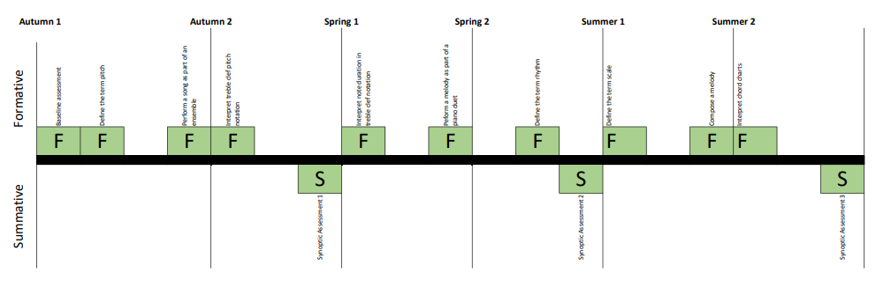

Baseline assessment—allows for staff to gain an insight to the KS2 knowledge of the students
Define the term pitch – students understand what the word pitch means and how different pitches can be performed
Sing in an ensemble— ensures students are able to warm their voices up, sing within a limited range as a class
Interpret treble clef pitch notation – checks students can translate treble clef pitch into piano keys
Interpret treble clef note duration — checks students can translate treble clef note duration
Perform as part of a piano duet — a check that students can perform a more complex melody in a duet
Define the term rhythm – students understand what the word rhythm means
Define the term scale – students are able to explain what a scale in music is
Compose a melody – students are able to compose an introductory level melody
Interpret chord charts – students are able to translate ukulele chord charts into chords
Music Assessment Model: Year 8

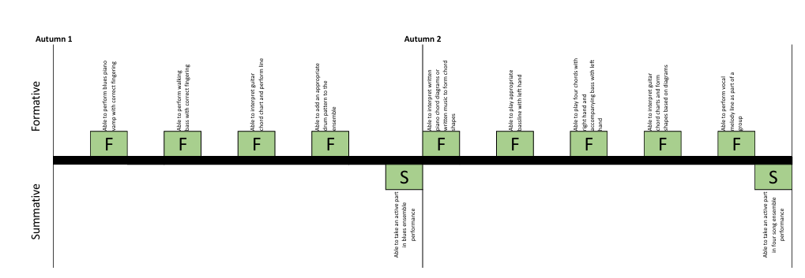
Perform 12 bar blues on the piano — ensures that students can read treble and bass clef notation, this is broken down into handed sections so that staff can check students can perform the right hand vamp, the left hand bass line and finally both together
Perform four chords on a piano —ensures students can read chords and can play four chords in time on the piano
Perform four chords on a guitar —ensures students can read chord charts and can play three single finger chords in time on the guitar
Perform rhythms on a drum kit — a check to ensure students can read a drum pattern and perform a drum rhythm as part of an ensemble.
Perform as part of an ensemble— ensures students are able to play their individual part in a group situation
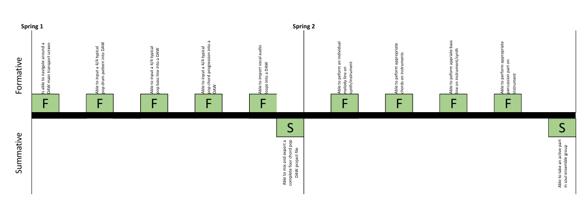
Able to import suitable loops into a DAW— a check to ensure students are able to operate a DAW and import samples
Able to mix using volume and panning– ensures students are able adjust volume and panning suitably within a DAW
Written assessment based upon blues and DAW's– checks students understanding or written music and DAW operation
Able to perform single melody or chord progression as part of large ensemble— ensures that students can read treble and bass clef notation, perform individually as part of larger ensemble

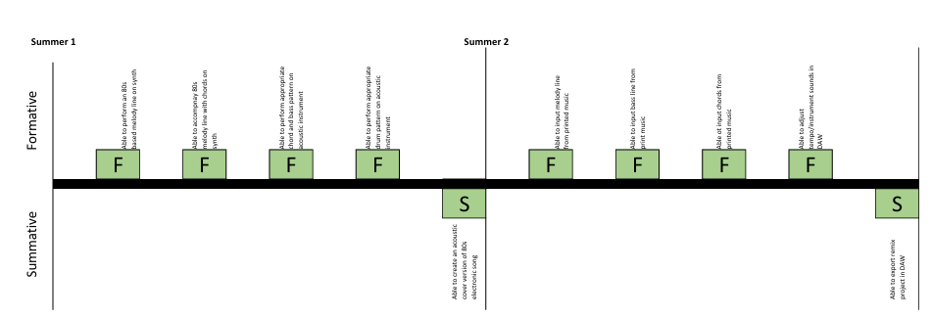
Able to perform stylistic version of electronic melody – Ensures students are able to perform more challenging melodic line using piano
Able to perform appropriate guitar chords – checks students are able to perform guitar chords fluently
Able to perform vocal lines – a check to ensure students are able to perform popular song verse chorus lyrics
Able to cover songs successfully in an ensemble - a check to make sure students are able to perform their own version of an electronic song using acoustic instruments
Able to input and compose a drum track line – a check to ensure students are able to input rhythmically notes correctly into DAW
Able to input notes in a melody line – ensures students are able to input correctly pitched notes into DAW
Able to input chords in a DAW – a check to make sure students can input correct chord voicings into DAW
Able to export a final mix track – ensures students are to successfully create a final mp3 track

Music Assessment Model: Year 9 Autumn Term

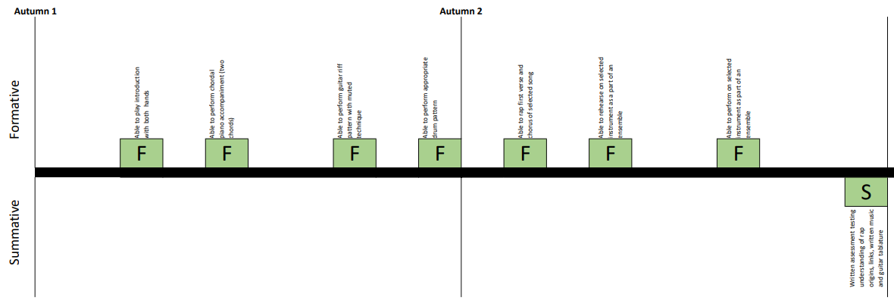

Able to appropriate piano chords and bass line – checks students are able to play piano chords & bass correctly
Able to perform guitar chords and bass line – checks students are to interpret and perform guitar chords/bass tab
Able to perform vocals - ensures students are able to understand and perform vocals with correct rhythms/pitch
Take an active role in group performance (drums, bass, piano or guitar) - a check to make sure students are actively involved in performance
Able to play introduction and two piano chords – checks students are able to play piano arpeggio & piano chords correctly
Able to perform guitar chords and bass line – checks students are to interpret and perform guitar chords/bass tab
Able to perform rap vocals - ensures students are able to understand and perform vocals with correct rhythms
Take an active role in group performance (drums, bass, piano or guitar) - a check to make sure students are actively involved in performance

Year 9 Spring Term

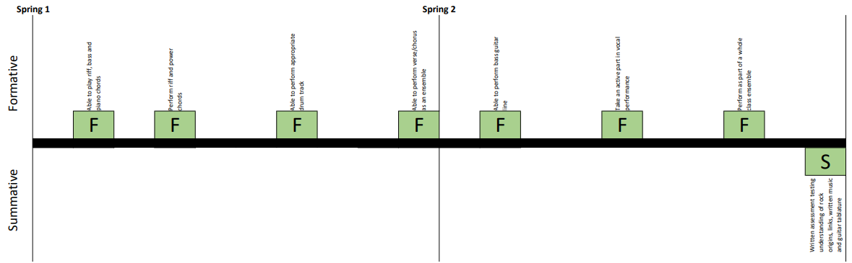

Able to input and compose a drum track line – a check to ensure students are able to input rhythmically notes correctly into DAW
Able to input notes in a melody line – ensures students are able to input correctly pitched notes into DAW
Able to input chords in a DAW – a check to make sure students can input correct chord voicings into DAW
Able to export a final mix track – ensures students are to successfully create a final mp3 track
Able to play riff, bass and piano chords – ensures students are able to interpret appropriate written music
Perform riff and power chords - a check to make sure students can interpret guitar tablature
Able to perform appropriate drum track – ensures students are able to perform correct drum parts
Able to perform verse/chorus as an ensemble – a check to make sure students are able to perform the verse vocals
Able to perform bass guitar line - a check to make sure students can interpret bass tablature
Take an active part in vocal performance – ensures students are able to perform an active role in verse/chorus vocal lines
Perform as part of a whole class ensemble - a check to make sure students are actively involved in performance

Year 9 Summer Term

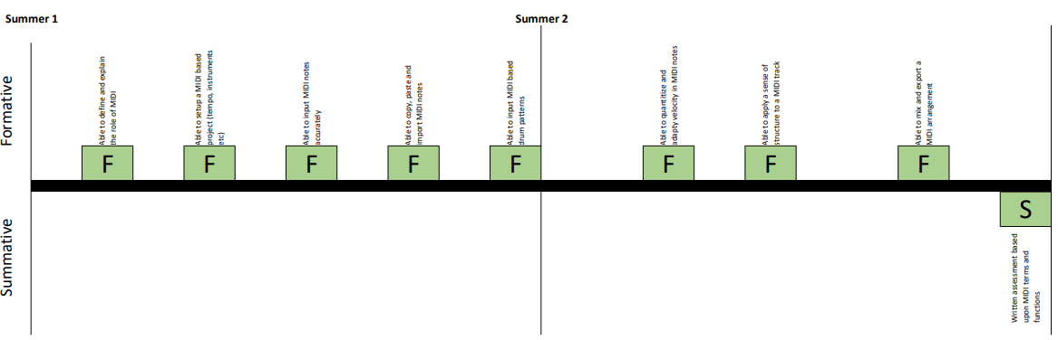

Able to define and explain compositional techniques in film music – Ensures students understand typical composition techniques utilized in film music
Able to perform a range of motif ideas from film genre – checks students are able to perform motif ideas fluently
Able to generate ideas for motif composition – a check to ensure students are able to begin the composition process
Able to use SFX ideas in music production appropriately – ensures students can utilize SFX and special function in a DAW to enhance their work
Able to mix and balance a film music composition – checks students are able to create a balanced final product read for export/bounce

