Our Lady’s Catholic College

Assessment in the English Curriculum
Our Lady’s Catholic College, Morecambe road, Lancaster, La12rx

Rationale for Assessment

“Student learning is slow, erratic, associative and cumulative.” Christine Counsell

We appreciate that students do not necessarily learn in a linear way and that we, as teachers of English must address this in all aspects of our practice. Effective assessment and pupil feedback is at the root of the English curriculum and its implementation here at OLCC. We appreciate that good assessment is two-fold in that it is an ‘assessment for learning and of learning.’ Assessment is integrated throughout our curriculum and is used to assess how well pupils have mastered core learning and to highlight misconceptions in the acquisition and application of knowledge and concepts. Teachers will make adaptions in response to assessment outcomes and pupils are given the opportunity to reflect and respond to feedback in a timely and appropriate way.
A three-stage framework of common assessment allows pupils and teachers to track the acquisition and application of knowledge in a clear and structured way within each unit of work:
Phase 1 – Consolidation and retrieval of knowledge
Phase 2 – Extending and developing application of knowledge
Phase 3 - Developing expertise and mastery when synthesising knowledge
Each assessment is common across the department and all pupils sit the same assessment at the specified hinge point in the curriculum sequence. The expectation is that staff respond to the information provided by the MIGs via re-teaching or addressing misconceptions before they continue with the delivery of the planned curriculum sequence. Pupils are encouraged to view feedback as an essential part of their curriculum journey and that acting upon it is critical in their development as agile learners.
KS3 Assessment Model
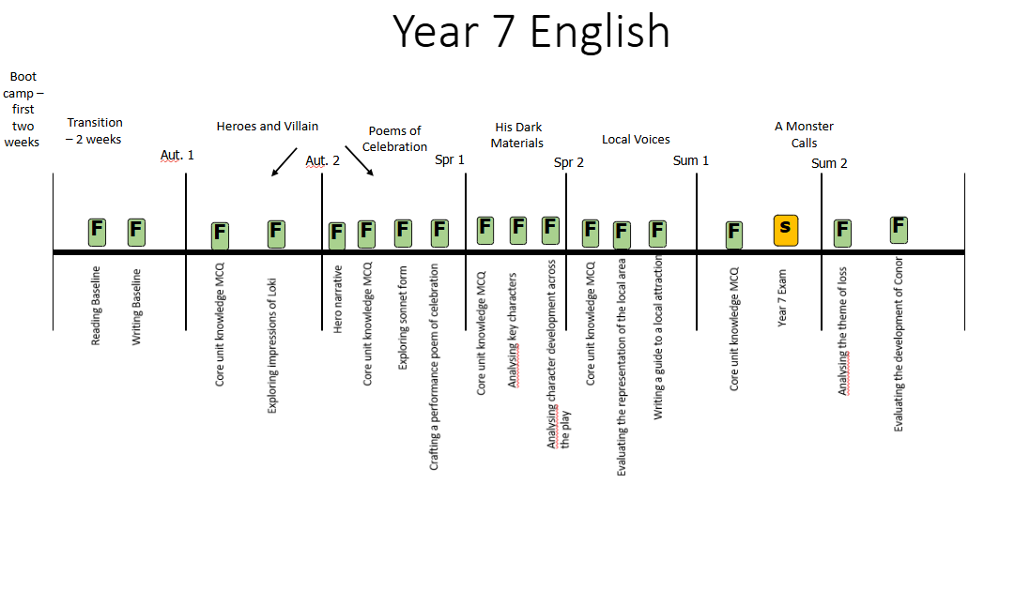
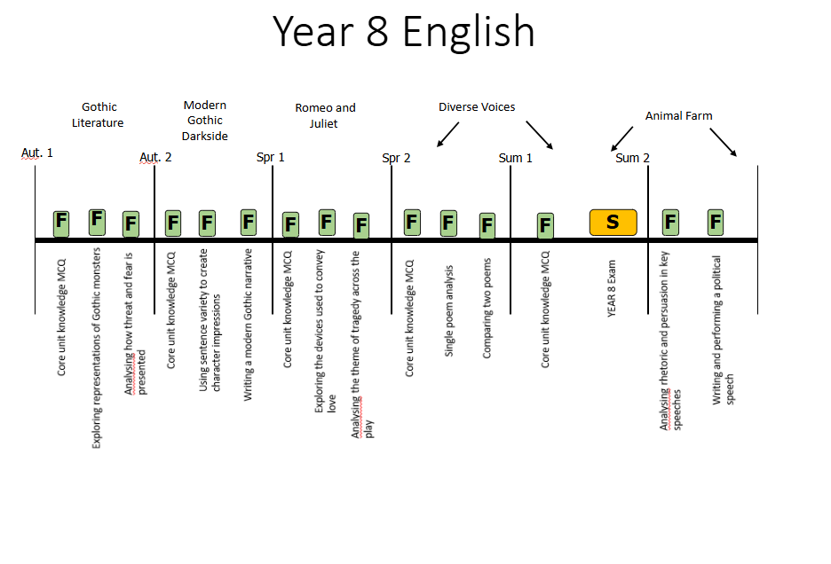
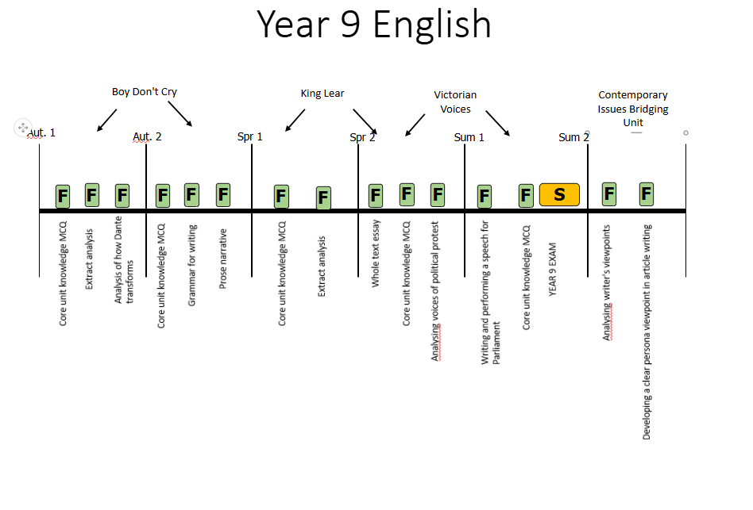
Synoptic Assessments

Our synoptic assessments are developed on the principle of desirable difficulties where prior learning is assessed in an unfamiliar context to ensure that there has been deep learning, not performance. The recall and retrieval questions aim to assess what pupils know and remember about the taught curriculum across key stage 3. Each synoptic is developed in a way that assesses the key component knowledge across all units of work and all year groups at KS3. We understand that it is important for pupils to build their schema of disciplinary knowledge and in particular their understanding of how to write in particular styles therefore, synoptic assessments also assess the students’ ability to answer English style questions eg. To evaluate and analyse as well as to write for the correct purpose and audience.

The synoptic assessments are cumulative and aim to give a clear picture of how well a student has understood the component knowledge addressed across the curriculum.

KS4 Assessment Model
At Key stage 4 we begin to prepare students for their external GCSE examinations. We do however understand the importance of ensuring that common formative assessments are carried out at specific hinge points in the sequence of learning in order to inform teaching and ensure that teachers can respond to misconceptions that arise before moving on with the planned sequence.
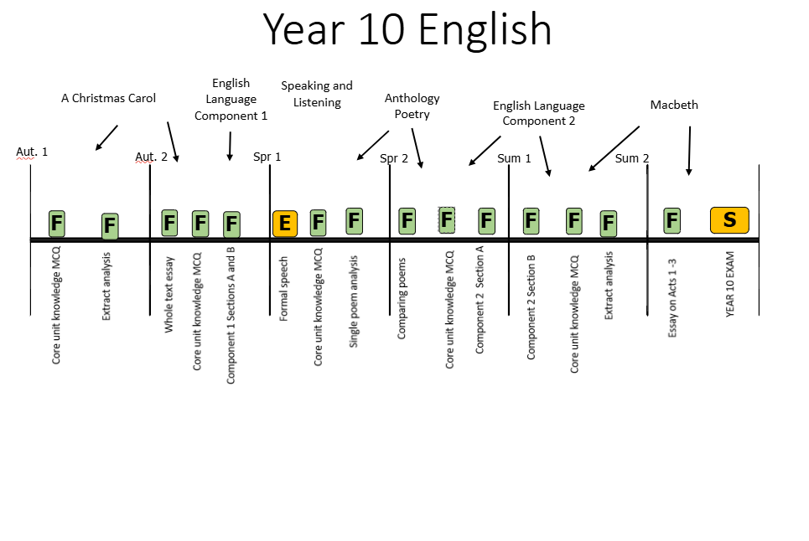

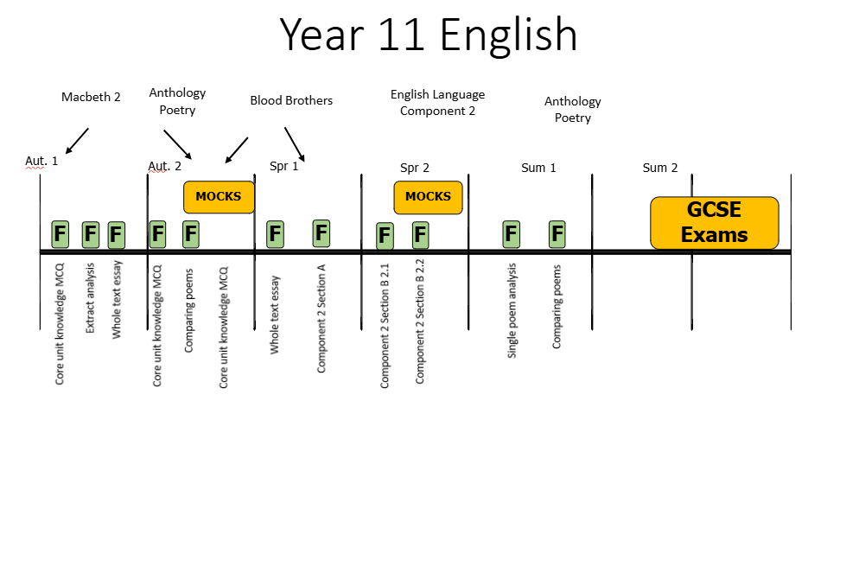
KS5 Assessment Model
At Key stage 5 we begin to prepare students for their AQA Language and Literature A-level examinations. Formative assessments are carried out at specific hinge points in the sequence of learning in order to inform teaching and ensure that teachers can respond to misconceptions that arise before moving on with the planned sequence.



