

Our Lady’s Catholic College Reading For Pleasure Booklist.
Reading for pleasure has the scientific research to support the statement that reading can have positive impacts on children, adults and their future. A study conducted by Clark and Rumbold (2006) identify the following benefits of reading for pleasure:
- Improving reading attainment and improving writing ability
- Text comprehension and grammar
- Breadth of vocabulary
- Positive reading attitudes
- Greater self-confidence as readers
- Pleasure in reading in later life
- General knowledge
- A better understanding of other cultures
- Community participation
- A greater insight to human nature and decision making

Year 9 Reading for Pleasure Books:

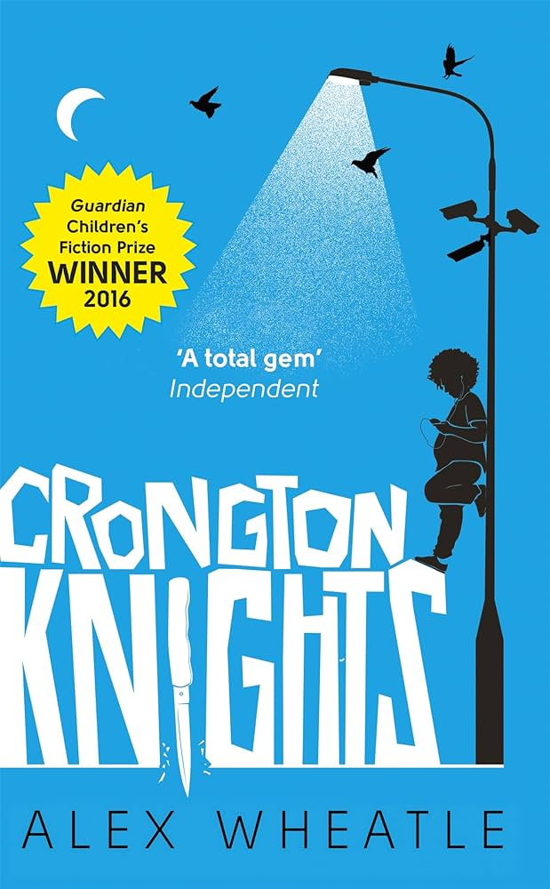 | Living on the South Crongton estate has its worries - and life for McKay has been even tougher since his mum died. His dad has been working all hours to keep the bailiffs from their door. His brother is always out riding the streets at night, tempting trouble. And now, having strayed off his turf on a 'heroic' (if misguided) mission to help out a girl, McKay finds himself facing a friend's crazy ex-boyfriend, a group of kids on a mega power trip and a notoriously violent gangster with a vendetta that hits close to home.
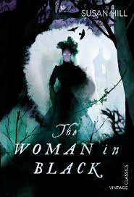 | Arthur Kipps, a junior solicitor, is summoned to attend the funeral of Mrs Alice Drablow, the sole inhabitant of Eel Marsh House. The house stands at the end of a causeway, wreathed in fog and mystery, but it is not until he glimpses a wasted young woman, dressed all in black, at the funeral, that a creeping sense of unease begins to take hold, a feeling deepened by the reluctance of the locals to talk of the woman in black - and her terrible purpose.
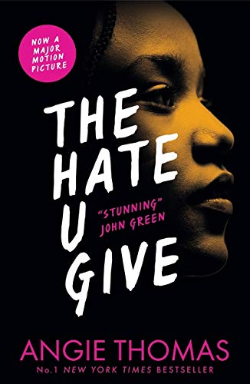 | Sixteen-year-old Starr Carter moves between two worlds: the poor neighborhood where she lives and the fancy suburban prep school she attends. The uneasy balance between these worlds is shattered when Starr witnesses the fatal shooting of her childhood best friend Khalil at the hands of a police officer. Khalil was unarmed.  Soon afterward, his death is a national headline. Some are calling him a thug, maybe even a drug dealer and a gangbanger. Protesters are taking to the streets in Khalil’s name. Some cops and the local drug lord try to intimidate Starr and her family. What everyone wants to know is: what really went down that night? And the only person alive who can answer that is Starr.  But what Starr does—or does not—say could upend her community. It could also endanger her life.  Inspired by the Black Lives Matter movement, this is a powerful and gripping YA novel about one girl's struggle for justice.
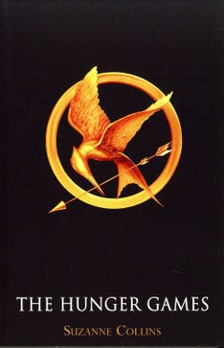 | Born into Panem’s poorest district, Katniss relied on her hunting skills to feed her family; now in the Hunger Games arena, those skills must protect her from the rich districts’ well-trained competitors. While allies prove helpful at first, only one person can live.
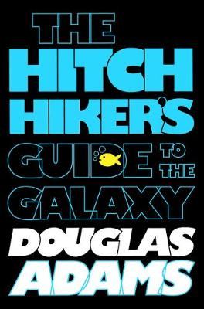 | Go on a galactic adventure with the last human on Earth, his alien best friend, and a depressed android. Introducing younger readers to The Hitchhiker’s Guide to the Galaxy, this YA edition of the funny sci-fi classic includes an introduction from Artemis Fowl author Eoin Colfer. One Thursday lunchtime the Earth gets unexpectedly demolished to make way for a new hyperspace bypass. It’s the final straw for Arthur Dent, who has already had his house bulldozed that morning. But for Arthur, that is only the beginning . . . In the seconds before global obliteration, Arthur is plucked from the planet by his friend Ford Prefect – and together the pair venture out across the galaxy on the craziest, strangest road trip of all time!  Totally hilarious, The Hitchhiker’s Guide to the Galaxy has been a radio show, TV show, stage play, comic book and film, and is and a work of utter comic genius from Douglas Adams.
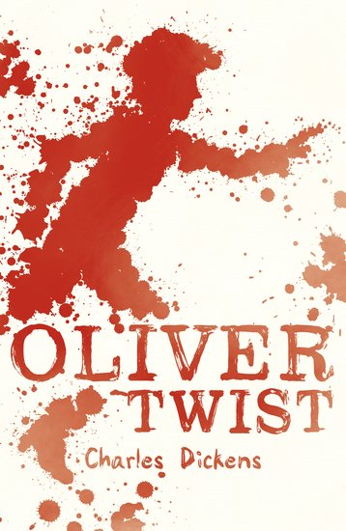 | Oliver Twist is Charles Dickens's second novel, and was first published as a serial from 1837 to 1839. The story centres on orphan Oliver Twist, born in a workhouse and sold into apprenticeship with an undertaker. After escaping, Oliver travels to London, where he meets the "Artful Dodger", a member of a gang of juvenile pickpockets led by the elderly criminal Fagin. Oliver Twist is notable for its unromantic portrayal of criminals and their sordid lives, as well as for exposing the cruel treatment of the many orphans in London in the mid-19th century. In this early example of the social novel, Dickens satirises the hypocrisies of his time, including child labour, the recruitment of children as criminals, and the presence of street children.
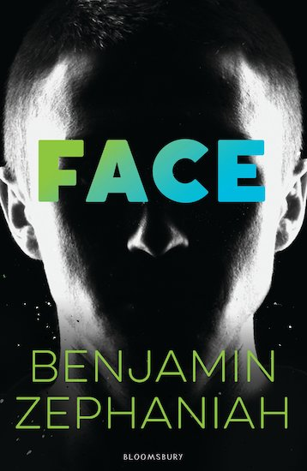 | Brutally brilliant. Teen joyrider Martin just lost his pretty face. Is it a chance to find his conscience? Good-looking and cocky, Martin is no angel. But when he’s mutilated in a joyriding smash, he ends up looking more like the devil. How will his mates treat him now? What about girls? People can hardly even stand to look at him. The East End hasn’t changed, with its chip shops, curry houses and rap clubs. But for the first time ever, Martin is being forced to look deep inside. And he’s starting to see that when people sneer at his broken face, they’re doing just what his own gang always did to the local blacks and Asians…
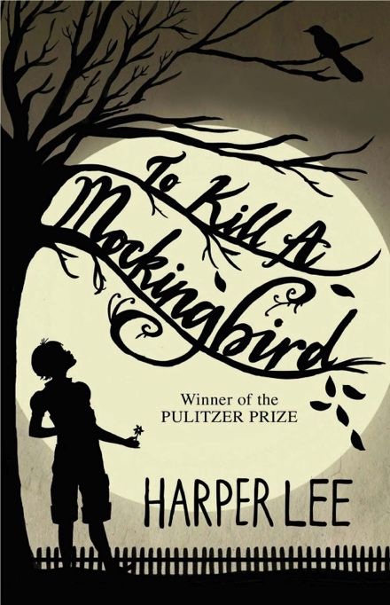 | A lawyer's advice to his children as he defends the real mockingbird of Harper Lee's classic novel - a black man falsely charged with the rape of a white girl. Through the young eyes of Scout and Jem Finch, Harper Lee explores with exuberant humour the irrationality of adult attitudes to race and class in the Deep South of the 1930s. The conscience of a town steeped in prejudice, violence and hypocrisy is pricked by the stamina of one man's struggle for justice. But the weight of history will only tolerate so much.  To Kill a Mockingbird is a coming-of-age story, an anti-racist novel, a historical drama of the Great Depression and a sublime example of the Southern writing tradition.

