

Our Lady’s Catholic College Reading For Pleasure Booklist.
Reading for pleasure has the scientific research to support the statement that reading can have positive impacts on children, adults and their future. A study conducted by Clark and Rumbold (2006) identify the following benefits of reading for pleasure:
- Improving reading attainment and improving writing ability
- Text comprehension and grammar
- Breadth of vocabulary
- Positive reading attitudes
- Greater self-confidence as readers
- Pleasure in reading in later life
- General knowledge
- A better understanding of other cultures
- Community participation
- A greater insight to human nature and decision making

Year 8 Reading for Pleasure Books:

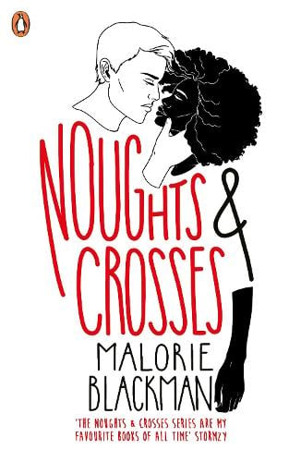 | "A book that dared to go where no one thought you could with young audiences because it raises tough stuff to do with race."  It takes a brave author such as Malorie Blackman to consider a sequence of the like of Noughts and Crosses and to pull it off with utmost aplomb. Award-winning author Blackman has tackled the issues of racism and prejudice in a world set in an alternate historical reality. Although 11 year olds will take great joy and learn much from reading this first one in the sequence, adults will devour it with equal enthusiasm. The contrast of the two main protagonists makes the novel totally compelling and the writing style is both original and superbly paced. The plot unravels at the pace of a thriller and as a consequence it’s a book that is almost impossible to put down.

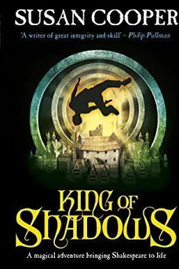 | Nathan Field, a talented young actor, arrives at the newly rebuilt Globe Theatre in London to play Puck in A Midsummer Night's Dream. As rehearsals begin, eerie echoes of the past begin to haunt Nat, and he falls sick with a mysterious sickness.  When he wakes, Nat finds himself in 1599, an actor at the original Globe - and his co-star is none other than the King of Shadows himself: William Shakespeare.  Nat's new life is full of excitement, danger and the passionate friendship that he has longed for since the tragic death of his parents. But why has he been sent to the past - and is he trapped there forever?
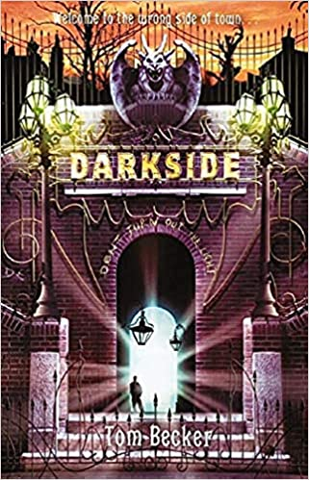 | Your home's been attacked. Your dad's in an asylum. You're running for your life. And there's nowhere to hide. You've stumbled on the city's greatest secret: Darkside. Incredibly dangerous and unimaginably exciting. Darkside is ruled by Jack the Ripper's children - a place where nightmares walk the streets. You think you're in trouble now, but your problems have just begun.
 | Homeless on the streets of London, 16 year old Link feels he has become an invisible outcast. When he meets streetwise Ginger, life becomes more bearable and he learns the tricks of survival. But when Ginger goes missing, Link feels a sickening sense of foreboding...
 | Come with me, Zen Starling, she had said. The girl in the red coat. But how did she know his name?  The Great Network is a place of drones and androids, maintenance spiders and Station Angels. The place of the thousand gates, where sentient trains criss-cross the galaxy in a heartbeat.  Zen Starling is a petty thief, a street urchin from Thunder City.  So when mysterious stranger Raven sends Zen and his new friend Nova on a mission to infiltrate the Emperor's train, he jumps at the chance to traverse the Great Network, to cross the galaxy in a heartbeat, to meet interesting people - and to steal their stuff.  But the Great Network is a dangerous place, and Zen has no idea where his journey will take him.
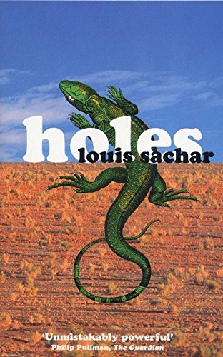 | Stanley Yelnats is under a curse. A curse that began with his no-good-dirty-rotten-pig-stealing-great-great-grandfather and has since followed generations of Yelnats. Now Stanley has been unjustly sent to a boys’ detention center, Camp Green Lake, where the boys build character by spending all day, every day digging holes exactly five feet wide and five feet deep. There is no lake at Camp Green Lake. But there are an awful lot of holes.  It doesn’t take long for Stanley to realize there’s more than character improvement going on at Camp Green Lake. The boys are digging holes because the warden is looking for something. But what could be buried under a dried-up lake? Stanley tries to dig up the truth in this inventive and darkly humorous tale of crime and punishment—and redemption.
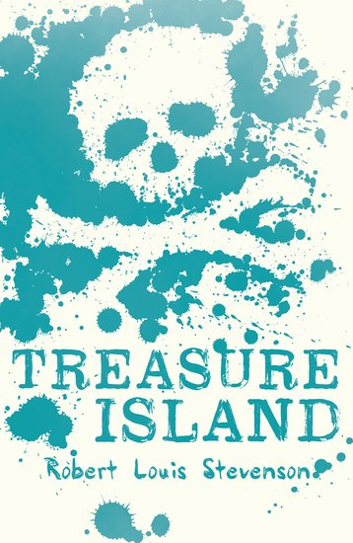 | Jim Hawkins is the son of the innkeepers of the Admiral Benbow near Devon and becomes fascinated by a mysterious lodger, the old seaman Billy Bones. It soon becomes apparent to Jim that Billy Bones is in hiding from a man with one wooden leg and he is also in possession of a much sought after pirate’s treasure chest. When Billy Bones suddenly drops dead, Jim flees, taking with him an oilskin packet from within the chest. It turns out that Jim has taken a map detailing the whereabouts of Captain Flint’s treasure. A swash-buckling adventure aboard the Hispaniola ensues as Jim attempts to track down the treasure with the help of a one-legged sea cook Long John Silver, Captain Alexander Smollett, Squire Trelawney and Dr. Livesey among others. But all is not as it seems. Is Long John Silver really trustworthy? After all Bones did warn him of a man with one leg…
 | Raphael lives on a dumpsite, eking out a living sifting through rubbish. One unlucky-lucky day, he makes an extraordinary and deadly discovery. Now he and his two friends, Gardo and Rat, are wanted by the corrupt forces that run the city and will stop at nothing to get back what they've lost.  From the slums to the mansions of the elite, it's going to take all of their quick-thinking and fast-talking to stay ahead. And to stay alive.

