

Our Lady’s Catholic College Reading For Pleasure Booklist.
Reading for pleasure has the scientific research to support the statement that reading can have positive impacts on children, adults and their future. A study conducted by Clark and Rumbold (2006) identify the following benefits of reading for pleasure:
- Improving reading attainment and improving writing ability
- Text comprehension and grammar
- Breadth of vocabulary
- Positive reading attitudes
- Greater self-confidence as readers
- Pleasure in reading in later life
- General knowledge
- A better understanding of other cultures
- Community participation
- A greater insight to human nature and decision making

Year 7 Reading for Pleasure Books:

 | It’s just a normal trip to London – isn’t it? Alem is seriously excited. He’s never been out of Ethiopia before. It’s his first foreign holiday! He and his dad have a great few days together – until Alem wakes up in their B&B one morning to find his dad gone. At first Alem is stumped. But then the hotel owner hands him a letter from his dad: a letter that explains the unthinkable. Because of Ethopia’s political problems, he and Alem’s mother felt it would be safer to take Alem to Britain and leave him there. Now Alem is on his own – in the hands of social services and the Refugee Council. What kind of future awaits this refugee boy?

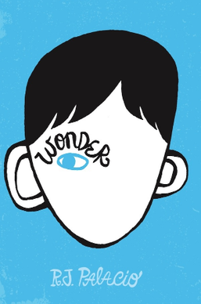 | 'My name is August. I won't describe what I look like. Whatever you're thinking, it's probably worse.'  Auggie wants to be an ordinary ten-year-old. He does ordinary things - eating ice cream, playing on his Xbox. He feels ordinary - inside. But ordinary kids don't make other ordinary kids run away screaming in playgrounds. Ordinary kids aren't stared at wherever they go.  Born with a terrible facial abnormality, Auggie has been home-schooled by his parents his whole life. Now, for the first time, he's being sent to a real school - and he's dreading it. All he wants is to be accepted - but can he convince his new classmates that he's just like them, underneath it all?
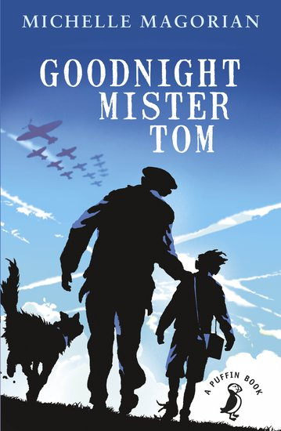 | Tom tucked a blanket round him, drew up a chair by the fire and watched Willie fall asleep. The tales he had heard about evacuees didn't seem to fit Willie. 'Ungrateful' and 'wild' were the adjectives he had heard used, or just plain 'homesick'. He was quite unprepared for this timid, sickly little specimen.  Britain, 1940. With World War Two raging all around, young children are being sent from their homes in the city to the countryside for safety. When eight-year-old Willie Beech first arrives on Tom Oakley's doorstep, neither are quite sure what to make of each another.  .  Brought up in terrible poverty, Willie is terribly shy, and totally unprepared for village life - but the gruff-but-gentle 'Mister Tom' quickly takes him under his wing. Neither he nor Willie could ever have predicted the journey they will go on together - nor the unbreakable bond that will be formed.
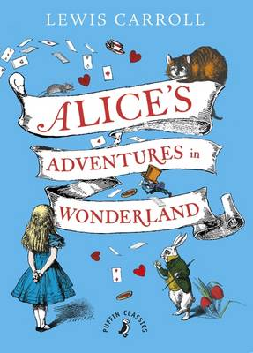 | Down the rabbit hole away little Alice goes. Follow her at your own peril, but beware of the world you are about to enter. One with a decapitation-crazed queen, an unintelligible duchess, a sleepy dormouse, a chronically late rabbit, a witty Cheshire cat, a blue hookah-smoking caterpillar, a Hatter and a March Hare hosting a mad tea party, and a caucus race so bewildering that the best way to explain it is just to do it.
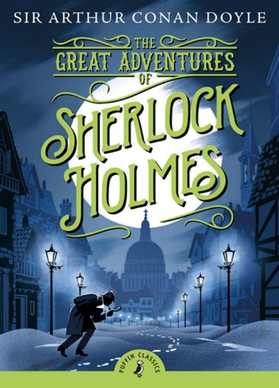 | The Adventures of Sherlock Holmes is the series of short stories that made the fortunes of the Strand magazine, in which they were first published, and won immense popularity for Sherlock Holmes and Dr Watson. The detective is at the height of his powers and the volume is full of famous cases, including 'The Red-Headed League', 'The Blue Carbuncle', and 'The Speckled Band'
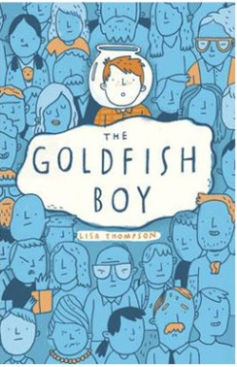 | A story about finding friendship when you're lonely - and hope when all you feel is fear.  Twelve-year-old Matthew is trapped in his bedroom by crippling OCD, spending most of his time staring out of his window as the inhabitants of Chestnut Close go about their business.  Until the day he is the last person to see his next door neighbour's toddler, Teddy, before he goes missing.  Matthew must turn detective and unravel the mystery of Teddy's disappearance - with the help of a brilliant cast of supporting characters.  Page-turning, heartbreaking, but ultimately life-affirming, this story is perfect for fans of Can You See Me, The Curious Incident of the Dog in the Night Time and Wonder.
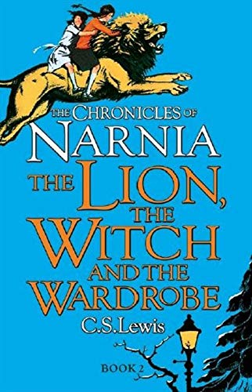 | Four adventurous siblings―Peter, Susan, Edmund, and Lucy Pevensie― step through a wardrobe door and into the land of Narnia, a land frozen in eternal winter and enslaved by the power of the White Witch. But when almost all hope is lost, the return of the Great Lion, Aslan, signals a great change . . . and a great sacrifice.  The Lion, the Witch and the Wardrobe is the second book in C. S. Lewis’s classic fantasy series, which has been drawing readers of all ages into a magical land with unforgettable characters for over sixty years. This is a stand-alone read, but if you would like to explore more of the Narnian realm, pick up The Horse and His Boy, the third book in The Chronicles of Narnia.
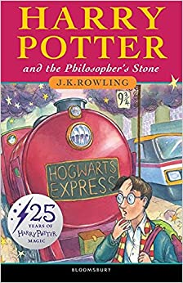 | Harry Potter lives in the cupboard under the stairs at his uncle and aunt's house at number four, Privet Drive - until the day when a mysterious letter arrives from Hogwarts School of Witchcraft and Wizardry, and a giant on a flying motorcycle arrives to change his life with four simple words: 'Harry - yer a wizard.
 | In the first book in the number one bestselling Alex Rider series by Anthony Horowitz, fourteen-year-old Alex is forcibly recruited into MI6. Armed with secret gadgets, he is sent to investigate Herod Sayle, a man who is offering state-of-the-art Stormbreaker computers to every school in the country. But the teenage spy soon finds himself in mortal danger

