Our Lady’s Catholic College

KS4 ASSESSMENT - MUSIC
Our Lady’s Catholic College, Morecambe road, Lancaster, La12rx


Assessment and MIG’s in Music

The department uses a variety of both formative and summative assessments to inform staff of students understanding and progress. The component knowledge of each topic are assessed using Multiple Inadequate Glances (MIGs) to formatively assess the understanding of the component and allow for responsive teaching before moving on. These are common across the department to allow for consistency, highlighted on the schemes of work and a common logo on
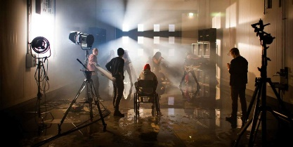
the teaching resources.

The MIG’s are clearly outlined on all key stage 4 schemes of work and are then resourced within the departmental shared area. Also within the shared area is a spreadsheet where staff save all of the assessment data from the MIG’s, this can then be accessed and used by staff to assess the understanding of the class and allow for interventions or responsive teaching to take place.

Each of the MIG’s take place after a component of knowledge or a particular musical skill has been taught. This then allows staff to assess the understanding of the class before building upon that component knowledge, in the next sequence within the scheme of work. It is dependent upon what is being assessed as to what format the MIG has. There is a mixture of knowledge and literacy tests to ensure students are able to describe, explain and analyse a range of music. Additionally, there are checks to ensure students are able to interpret a range of written music, develop instrument techniques, performance and composition skills.

As this is the first year of MIGs being introduced into schemes of work, the effectiveness of the MIGs are reviewed at the end of each scheme of work. This is to ensure we are able to effectively assess the students on the key technical, constructive and expressive musical knowledge. Student voice will also be collated throughout the year, to allow a full evaluation to take place.

Music Assessment Model: Year 10 Autumn Term
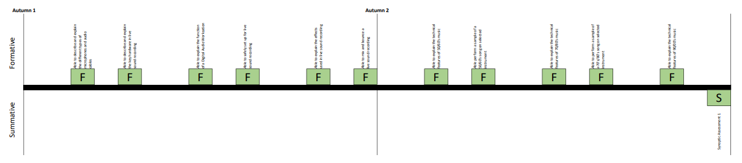

Able to describe and explain the key hardware in live sound recording — ensures students know the kit required for live sound recording and understand how it fits together
Able to explain the function of a digital audio workstation — a check to ensure students know what a DAW is for and why we use it
Able to set up live sound recording safely — checks students can set up a live recording session safely
Able to explain the effects used in live sound recording — a check that students understand the names of the effects used in live sound recording, why and how we apply them to audio
Able to mix and bounce a live sound recording – a check that students can adjust track levels and panning before exporting their finished track

Able to explain the technical features of 1950/60’s music—checks students understand how music sounds and is composed from a given era

Able to perform a sample of a 1950/60’s song on selected instrument – checks students are able to reinterpret music from a given era

Able to explain the technical features of 1970/80’s music—checks students understand how music sounds and is composed from a given era

Able to perform a sample of a 1970/80’s song on selected instrument – checks students are able to reinterpret music from a given era

Able to explain the technical features of 1990/2000’s music—checks students understand how music sounds and is composed from a given era

Able to perform a sample of a 1990/2000’s song on selected instrument – checks students are able to reinterpret music from a given era

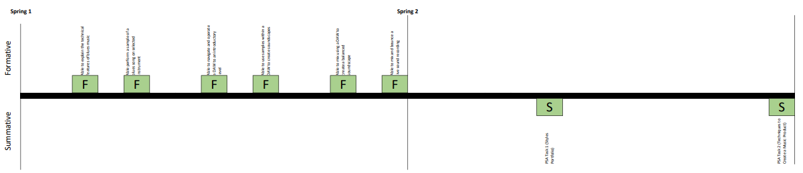
Music Assessment Model: Year 10 Spring Term

Able to explain the technical features of blues music—checks students understand how music sounds and is composed from a given era
Able to perform a sample of a blues song on selected instrument – checks students are able to reinterpret music from a given era
Able to operate a DAW— checks students have the basic skills to navigate a digital audio workstation
Able to use samples with a DAW – checks students are able to access samples and integrate them into a composition
Able to mix using a DAW — checks students understand how to adjust track levels and panning with a DAW

Music Assessment Model: Year 10 Summer Term

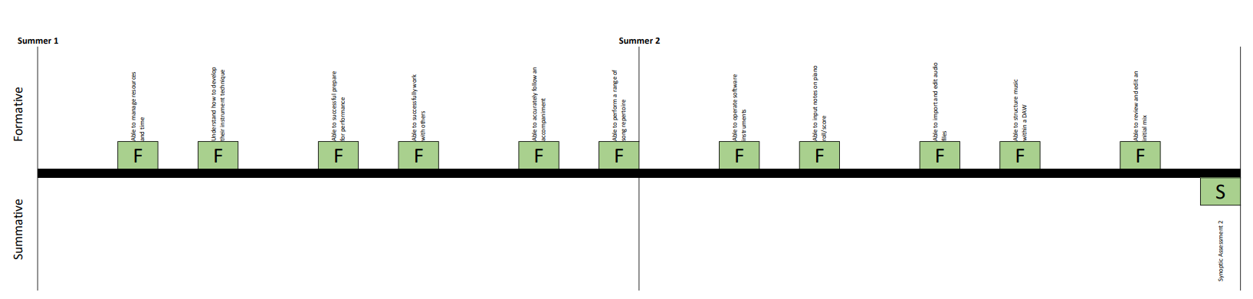

Able to manage resources and time — checks that students are able to plan and work with a level of independence
Understand how to develop their instrument technique – ensures students know what they need to do to improve their playing technique
Able to successfully prepare for performance —checks that students are on track with their preparation and understand how to progress
Able to successfully work with others — a check that students are able to work as part of group while making progress
Able to accurately follow an accompaniment— ensures students can play along with a backing track or ensemble
Able to perform a range of song repertoire — a check that students can perform songs from different genres

Music Assessment Model: Year 11 Autumn Term

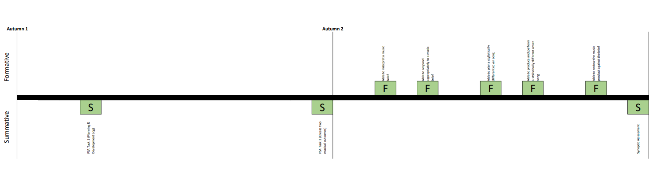

Able to interpret a music brief—checks students are able to understand a music brief
Able to respond appropriately to a music brief– ensures students can respond appropriately to a given music brief
Able to plan a stylistically different cover song— checks students are able to consider how they will cover a song in a different style
Able to produce and perform a stylistically different cover song– checks students are able to produce or perform a cover song in a different genre
Able to review the music product against the brief— ensures students understand how to review their product in comparison to the brief

Music Assessment Model: Year 11 Spring Term



