Our Lady’s Catholic College

PILLARS OF PROGRESSion - KS3 MUSIC
Our Lady’s Catholic College, Morecambe road, Lancaster, La12rx

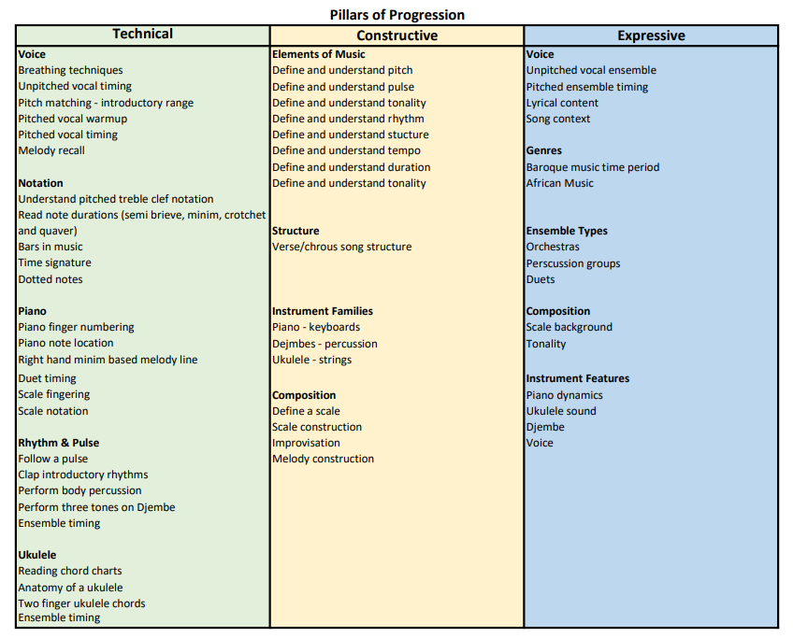

YEAR 7

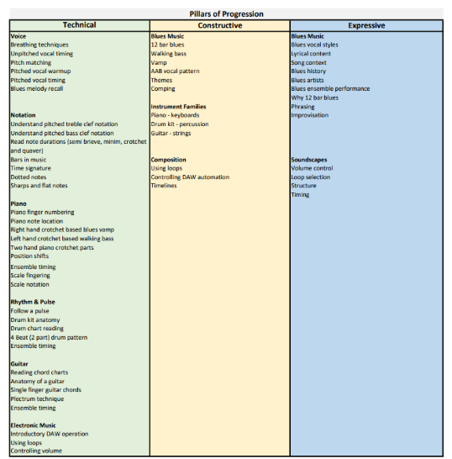
YEAR 8


YEAR 9

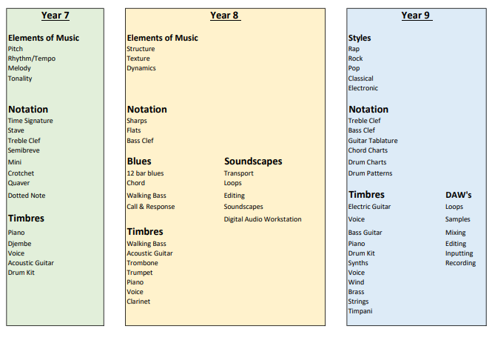
KS3 Terminology flightpath

