Our Lady’s Catholic College

Computer science Assessmnent model
Our Lady’s Catholic College, Morecambe road, Lancaster, La12rx

What is the aim of assessment in KS3 Computing?

In Computing at Our Lady’s our aim is that our students learn their curriculum well so that they know more and can do more. This knowledge and capability will prepare students well for success in Key Stage 4 and beyond. It is also important that any gaps are identified in key stage 3 so that these can be effectively addressed.
To do this we use both:
- Formative assessment – as an ongoing element of our teaching to check for student understanding
- Summative assessment – to assess how well students are learning and remembering the curriculum
What do we assess in KS3 Computing?

In KS3 Computing we assess students’ knowledge in two ways. The depth of their:
Declarative knowledge – how well a student knows the core facts and ideas within our subject
Procedural knowledge – how well a student is able to apply these facts and ideas. This is often through practical skills, solving problems or constructing programs.

The blend of these two aspects of knowledge allows a student to know both ‘what’ and ‘how to’.
What does formative assessment look like in Computing?

- Checking for student understanding in Computing takes the form of:
- Questioning in lessons
- Live marking of students’ work
- Quizzes and tests in lessons or set as homework which formulate many of our MIGs (Multiple Inadequate Glances)
- Other forms of retrieval practice for students

As a department we use this formative assessment to help plan lessons and provide feedback to students about what they need to do next. Such feedback concentrates on students’ learning gaps and how to close these.

What does summative assessment look like in Computing?

Assessing how well students are learning and remembering the curriculum takes the form of:

- A test, exam or assessment online
- An extended piece or portfolio of work that builds up over the course of a sequence of learning.

Our Lady’s KS3 Computer Science Assessment Model
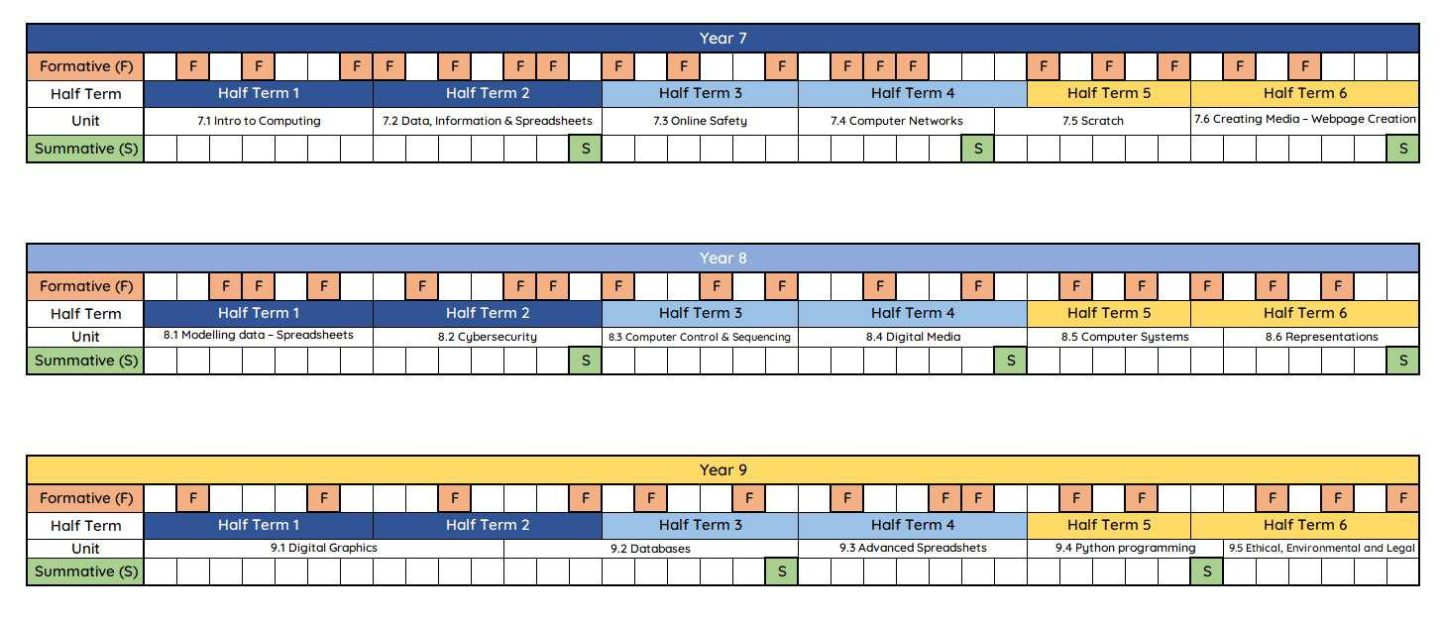

ggggggg

