Our Lady’s Catholic College

Assessment in the Sociology Curriculum
Our Lady’s Catholic College, Morecambe road, Lancaster, La12rx

Rationale for Assessment

Formative Assessment
In sociology we understand that formative assessment is an integral part of delivering a responsive curriculum. Assessment is integrated throughout our curriculum and is used to assess how well the curriculum has been understood and remembered and to highlight misconceptions pupils may have developed in order to determine how to respond to the needs of the students in class.

At key moments within the sequence of learning, students complete a formative assessment, these will range from low stakes knowledge quizzes to longer writing pieces that assess how well each component has been understood and determines the misconceptions and areas of development that need to be addressed before they continue with the sequence of learning.
Each assessment is common across the department and all pupils sit the same assessment at the specified hinge point in the curriculum sequence. The expectation is that staff respond to the information provided by the MIGs via re-teaching or addressing misconceptions before they continue with the delivery of the planned curriculum sequence.

Synoptic Assessments

Our synoptic assessments are developed on the principle of desirable difficulties where prior learning is assessed in an unfamiliar context to ensure that there has been deep learning, not performance. The recall and retrieval questions aim to assess what pupils know and remember about the taught curriculum across key stage 5. Each synoptic is developed in a way that assesses the key component knowledge across all units of work and all year groups at KS5. We understand that it is important for pupils to build their schema of disciplinary knowledge and in particular their understanding of how to use are variety of skills of communication including description, explanation, evaluation and analysis.
The synoptic assessment is intended to be designed to ensure an element of surprise so that pupils are assessed on the depth of their knowledge and feel comfortable to deploy their knowledge no matter what the question stem is. We try to not fully rely on the generic past paper questions as we are aware that pupils must be equipped to answer a range and variety of hinge questions that could be formulated in any format within the exam specification.

Feedback
In sociology we believe that responsive teaching is integral to the development of pupil’s knowledge and skills. As part of this responsive teaching we ensure that verbal feedback is provide to individual pupils and to the class in throughout every lesson. We believe that written feedback is also very important and is an essential dialogue between our students and us to identify misconceptions, strengths and areas of development. All written feedback is given in an STA format. This means that pupils have a strength (S) in their work identified, a target (T) for improvement and they are then expected to take action (A) on the target set. We ensure that our feedback focuses on an actionable learning based target. This can appear in the form of a question or a series of specific improvements that the students act upon. We ensure that the pupils are given the time and the re teaching if necessary to successfully action the targets they are set. By doing this we ensure that pupils work and feedback is meaningful and the pupils use the feedback as part of their learning experience.

KS5 Assessment Model
At Key stage 5 we begin to prepare students for their AQA Sociology examinations. Formative assessments are carried out at specific hinge points in the sequence of learning in order to inform teaching and ensure that teachers can respond to misconceptions that arise before moving on with the planned sequence.
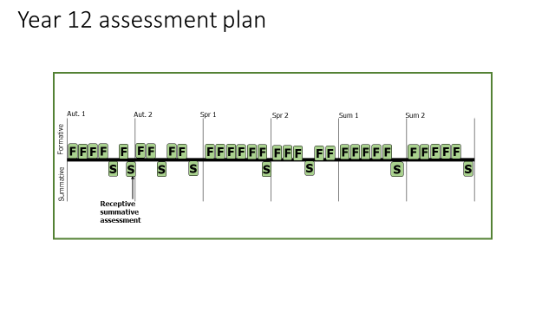

Autumn Term 1
MIG 1 – Skill-description Knowledge- social processes
MIG 2 focus - Skill-explanation Knowledge- Functionalism
MIG 3 focus - Skill- description & explanation Knowledge- Marxism
MIG 4 focus - Skill- description & explanation evaluation Knowledge- Feminism
MIG 5 focus- Summative Assessment
MIG 6 focus - Skill- description & explanation evaluation Knowledge- Interactionism
MIG 7 focus - End of unit Summative Assessment
Autumn Term 2
MIG 1 – Skill- description & explanation Knowledge- Functionalist view of education
MIG 2 focus - Skill- description & explanation Knowledge- Marxist view of education
MIG 3 focus - Summative Assessment- Items based
MIG 4 focus - Skill- Recall Knowledge- Functionalism & Marxism
MIG 5 focus- Skill- description & explanation Knowledge- Interactionist view of education
MIG 6 focus - Summative Assessment- Items based
Spring Term 1
MIG 1 – Skill- Analysis Knowledge- Factors that impact on educational achievement
MIG 2- focus - Skill- description & explanation Knowledge- Gender and educational achievement
MIG-3 focus - Skill- Analysis and evaluation Knowledge- Ethnicity and educational achievement
MIG 4 focus - Skill- description & explanation Knowledge- Educational reform
MIG 5 focus- Skill- Analysis and evaluation Knowledge- Globalisation
MIG 6 focus - Summative Assessment
Spring Term 2
MIG 1 – Skill- describe and explain Knowledge- Family as a social construct
MIG 2- focus - Skill- description & explanation Knowledge- Functionalist view of the family
MIG-3 focus - Skill- description & explanation Knowledge- Marxist view of the family
MIG 4 focus - Summative Assessment- Item
MIG 5 focus- Skill-Recall Knowledge- Perspectives
MIG 6 focus - Skill- Analysis and evaluation Knowledge- Gender roles in the family
Summer Term 1
MIG 1 – Skill- describe and explain Knowledge- Postmodernist view of the family
MIG 2- focus - Skill- description & explanation Knowledge- Marriage and divorce
MIG-3 focus - Skill-Analysis and evaluation Knowledge- Childhood
MIG 4 focus - Skill- description & explanation Knowledge- Demography
MIG 5 focus- Summative Assessment
Summer Term 2
MIG 1 – Skill- describe and explain Knowledge- Belief systems
MIG 2- focus - Skill- description & explanation Knowledge- Functionalist perspectives on beliefs
MIG-3 focus - Skill- description & explanation Knowledge- Marxist perspectives on beliefs
MIG 4 focus - Skill- Analysis and evaluation Knowledge-Neo- Marxist perspectives on beliefs
MIG 5 focus- Summative Assessment
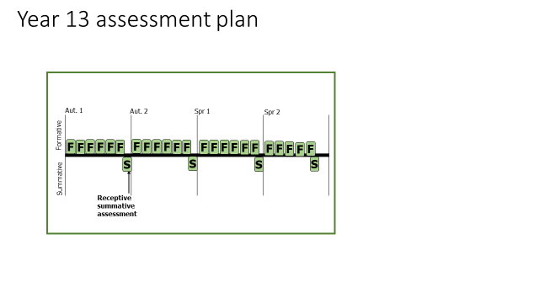

Autumn Term 1
MIG 1 – Skill- Analysis and evaluation Knowledge- Gender and beliefs
MIG 2- focus - Skill- description & explanation Knowledge- Class and beliefs
MIG-3 focus - Skill- Analysis and evaluation Knowledge- Ethnicity and beliefs
MIG 4 focus - Skill- description & explanation Knowledge- Typography of beliefs
MIG-5 focus - Skill- Analysis and evaluation Knowledge- Secularisation
MIG-6 focus - Skill- Analysis and evaluation Knowledge- Globalisation and beliefs
MIG 7 focus- Summative Assessment
Autumn Term 2
MIG 1 – Skill- description & explanation Knowledge- Crime and deviance definitions
MIG 2- focus - Skill- description & explanation Knowledge- Subcultures
MIG-3 focus - Skill- Analysis and evaluation Knowledge- Functionalist perspective of crime
MIG 4 focus - Skill- Analysis and evaluation Knowledge- Marxist perspective of crime
MIG-5 focus - Skill- Analysis and evaluation Knowledge- Secularisation
MIG-6 focus - Skill- description & explanation Knowledge- Realism
MIG 7 focus- Summative Assessment

Spring Term 1
MIG 1 – Skill- description & explanation Knowledge- Social class and crime
MIG 2- focus - Skill- description & explanation Knowledge- Gender and crime
MIG-3 focus - Skill- Analysis and evaluation Knowledge- Ethnicity and crime
MIG 4 focus - Skill- description & explanation Knowledge- Media and crime
MIG-5 focus - Skill- Analysis and evaluation Knowledge- Globalisation and crime
MIG 6 focus- Summative Assessment

Spring Term 2
MIG 1 – Skill- Analysis and evaluation Knowledge- Theories
MIG 2- focus - Skill- description & explanation Knowledge- Sociology and science
MIG-3 focus - Skill- Analysis and evaluation Knowledge- Deciding research approaches
MIG 4 focus - Skill- Analysis and evaluation Knowledge- Research methods in context
MIG-5 focus - Skill- description & explanation Knowledge- Observations
MIG 6 focus- Summative Assessment

