Our Lady’s Catholic College

PHYSICAL eDUCATION aSSESSMENT RATIONALE AND MIGS
Our Lady’s Catholic College, Morecambe road, Lancaster, La12rx

Rationale
KS3
The department uses a variety of both formative and summative assessments to inform staff of students understanding and progress. The component knowledge of each Activity is assessed using Multiple Inadequate Glances (MIGs) to formatively assess students understanding and allow for responsive teaching before moving on. These are common across the department to allow for consistency.
Each of the MIG’s take place after a component of knowledge or a particular skill has been taught. This then allows staff to assess the level of understanding of the class before building upon that component knowledge in the next sequence within the scheme of work. It is dependent upon what is being assessed as to what format the MIG has. There are a mixture of knowledge tests and practical evaluations that are used as a snapshot at each MIG point.
In KS3 the MIGS are used to assess both declarative(Head) and procedural(Hands) knowledge across a variety of activities and focus on key aspects that are often revisited on numerous activities to ensure students are able to transfer knowledge and skills. The MIGs are discussed both informally through day to day discussions as well as formally at Curriculum meetings to review their effectiveness.
There is a spreadsheet in the staff area where staff save all of the assessment data from the MIG’s, this can then be accessed and used by staff to assess the understanding of the class and allow for interventions or responsive teaching to take place. Also it allows for comparisons between MIGS and activities to be made to review and explore why understanding or performance is better in some areas than others. This then informs discussions at Curriculum meetings about how we teach.
Summative assessments take place throughout the year, as per the school assessment calendar. This is twice per year for KS3 where a summation of the MIGS is used to create a more holistic view of progress across a number of activities and skills.
KS4 & 5
In GCSE PE a variety of assessment activities are used for MIGs. Low stakes quizzes, lesson retrieval activities, past paper questions as well as STA marked tasks in line with the school assessment policy and practical assessments. Tasks build in complexity replicating the organization of the AQA question structure with students developing their ability to respond to AQA’s A01, A02 and A03 answers. Where possible past paper questions are used so that mark schemes can be utilised to ensure consistency of marking. End of Unit Tests assess the understanding of each topic area whilst tracking information is collected on a spreadsheet to allow reviewing of student progress across a number of topics and also to compare performance between topics so that teaching can be reviewed. The spreadsheet replicates the exam board overall breakdown so that aspects of underperformance can be highlighted quickly and interventions put into place.
In BTEC Sport a variety of assessment activities are used for MIGs. Starter retrieval tasks, quizzes, scenario practice and assessment of practical demonstration. This allows staff to review understanding and adapt tasks or re-teach aspects where necessary. The MIG tasks replicate the relative Course assessments that take place whether that is a Pearson Set Assignment(PSA) as in Level 2 Sport, an externally set exam or controlled assessment in Level 3 Sport.

PE Department MIG Assessments
KS3 Year 7
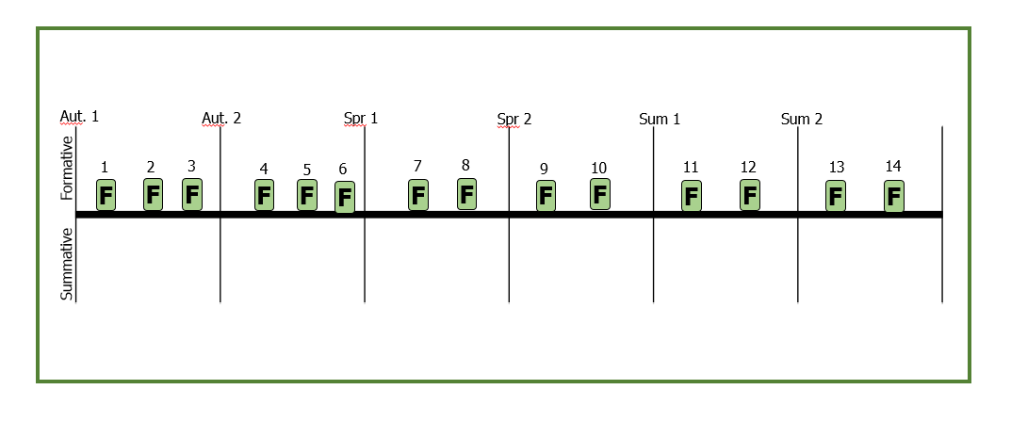
Year 7 BOYS PE KS3 |  | Year 7 GIRLS PE KS3
1 | Rugby Hands: Evading | 1 | Netball Hands: Passing and receiving
2 | Rugby Head: warm up basic importance and two parts | 2 | Netball Head: Creating Space
3 | Basketball Hands: Passing and receiving | 3 | Fitness Hands: Exercise replication
4 | Basketball Head: Creating space | 4 | Fitness Head: Knowledge of the body and muscles ( arms, legs, core )
5 | Handball Hands: Passing and receiving | 5 | Football Hands: Dribble
6 | Handball Head: Team Defending | 6 | Football Head: Knowledge and application of rules
7 | Fitness Hands: Exercise replication | 7 | Gymnastics Hands: Rolls
8 | Fitness Head: Knowledge of the body and muscles ( arms, legs, core ) | 8 | Gymnastics Head: Knowledge of the body and muscles
9 | Football Hands: Dribbling | 9 | Dance Hands: Timing
10 | Football Head: Knowledge and application of rules | 10 | Dance Head: Pathways
11 | Athletics Hands: Running technique | 11 | Athletics Hands: Running technique
12 | Athletics Head: Understanding of pacing. | 12 | Athletics Head: Understanding of pacing.
13 | Cricket Hands: Throwing and catching | 13 | Rounders Hands: Throwing and catching
14 | Cricket Head: Decision making and application of tactics | 14 | Rounders Head: Decision making and application of tactics

KS3 Year 8
Year 8 BOYS PE KS3 |  | Year 8 GIRLS PE KS3
1 | Rugby Hands: Passing and receiving | 1 | Netball Hands: Marking and Dodging
2 | Rugby Head: Warm up linked to muscles | 2 | Netball Head: Warm up linked to muscles
3 | Basketball Hands: Dribbling | 3 | Fitness Hands: Exercise replication:
4 | Basketball Head: Deception | 4 | Fitness Head: Knowledge of the body and muscles ( arms, legs, core, basic circuit and pulse taking)
5 | Handball Hands: Shooting | 5 | Football Hands: Passing
6 | Handball Head: Deception | 6 | Football Head: Knowledge and application of rules
7 | Fitness Hands: Exercise replication: | 7 | Gymnastics Hands: Balances
8 | Fitness Head: Knowledge of the body and muscles ( arms, legs, core, basic circuit and pulse taking) | 8 | Gymnastics Head: sequence planning
9 | Football Hands: Passing and creating space | 9 | Dance Hands: Dynamics
10 | Football Head: Knowledge and application of rules | 10 | Dance Head: Using levels
11 | Athletics Hands: Jumping technique high jump/long jump | 11 | Athletics Hands: Jumping technique high jump/long jump
12 | Athletics Head: Knowledge and application of rules | 12 | Athletics Head: Knowledge and application of rules
13 | Cricket Hands: Batting | 13 | Rounders Hands: Batting
14 | Cricket Head: Decision making and application of tactics | 14 | Rounders Head: Decision making and application of tactics

KS3 Year 9

Year 9 BOYS PE KS3 |  | Year 9 GIRLS PE KS3
1 | Rugby Hands: Tackling | 1 | Netball Hands: Shooting
2 | Rugby Head: Warm up with dynamic and static stretching | 2 | Netball Head: Warm up with dynamic and static stretching
3 | Basketball Hands: Shooting | 3 | Fitness Hands: Exercise replication
4 | Basketball Head: Ability to evaluate own and others performance | 4 | Fitness Head: Knowledge of the body, measuring fitness levels and how to improve fitness
5 | Handball Hands: Penetrating the D | 5 | Football Hands: Shooting
6 | Handball Head: Attacking Tactics | 6 | Football Head: Knowledge and application of rules
7 | Fitness Hands: Exercise replication | 7 | Gymnastics Hands: Flight
8 | Fitness Head: Knowledge of the body, measuring fitness levels and how to improve fitness | 8 | Gymnastics Head: Planning group sequences
9 | Football Hands: Shooting | 9 | Dance Hands: Gesture
10 | Football Head: Knowledge and application of rules | 10 | Dance Head: Developing a motif
11 | Athletics Hands: Shot put | 11 | Athletics Hands: Shot put
12 | Athletics Head: Transfer of momentum in Throws | 12 | Athletics Head: Transfer of momentum in Throws
13 | Cricket Hands: Bowling | 13 | Rounders Hands: Fielding
14 | Cricket Head: Decision making and application of tactics | 14 | Rounders Head: Decision making and application of tactics

Year 10 GCSE

1 | End of unit test Skeleton
2 | End of unit test muscles
3 | End of unit test cardiovascular system
4 | Quality marked work 1 Movement
5 | End of unit test respiratory system
6 | Building up a long answer response
7 | End of unit test components of fitness
8 | Quality marked work 2 COF strength
9 | AQA summative assessment anatomy and physiology
10 | End of unit test fitness tests
11 | Quality marked work 3 COF weakness
12 | End of unit test principals and types of training
13 | Quality marked work 4 (9 mark questions)
14 | End of unit test short and long term effects
15 | Quality marked work 5 Skill weakness
16 | End of unit test leavers planes axis
17 | AQA summary exam summer Mock
18 | Coursework review
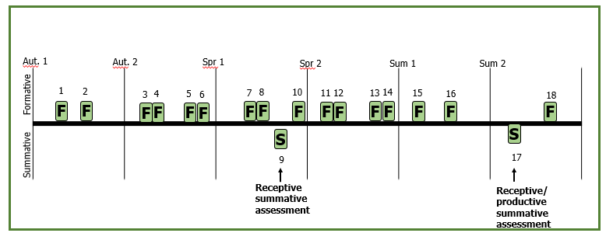

Year 11 GCSE
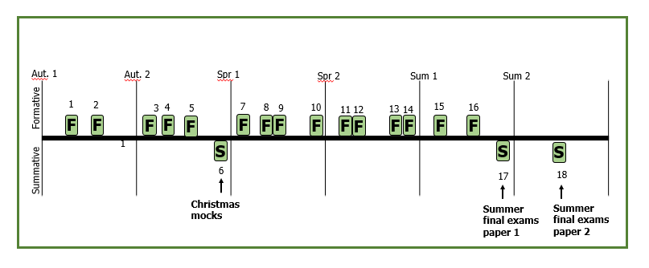

1 | End of unit test targets, goals and classifications of skill
2 | End of unit test guidance and info processing and Arousal
3 | Coursework deadline 1
4 | End of unit test motivation, aggression and personality types
5 | Building up a long answer response
6 | Christmas mocks
7 | Coursework final deadline and final mark
8 | End of unit test engagement patterns
9 | End of unit test obesity and somatotypes and nutrition
10 | End of unit test PED’s, etiquette and Hooliganism
11 | Quality marked work (9 mark question tech)
12 | End of unit test commercialization
13 | End of unit test Technology
14 | Quality marked work 9 mark questions
15 | Past paper questions
16 | Past paper questions
17 | AQA exam summer paper 1
18 | AQA exam summer paper 2

Year 10 BTEC Sport – Tech Award

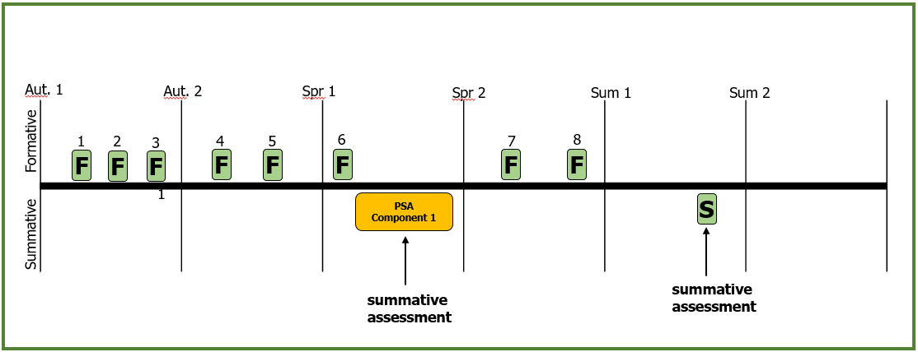
1 | Benefits of taking part in sporting activities
2 | Providers of Sport
3 | Barriers to participation and modifications.
4 | Clothing and Equipment for Participation
5 | Technology for Participation and it’s limitations
6 | Planning and Delivering a Warm-up
7 | Skills, isolated practices and competitive situations
8 | Key officials their roles and responsibilities

Year 11 BTEC Sport – Tech Award

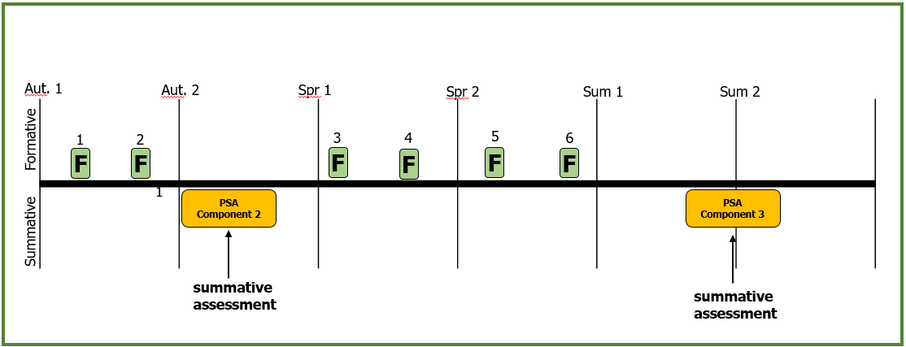
1 | Selecting Drills and conditioned Practices
2 | Planning a Training Session
3 | Fitness Training Principles
4 | Fitness Tests for different components of fitness.
5 | Training Methods
6 | Principles of training Program design

Year 12 BTEC Sport Unit 1

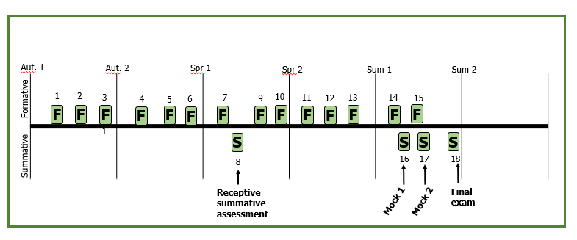

1 | End of unit test skeletal
2 | Retrieval task label diagram from memory
3 | Long answer question
4 | End of unit test Muscular
5 | Retrieval task label diagram from memory
6 | Interlinked long answer question
7 | End of unit test respiratory
8 | Summary test all topics so far
9 | Retrieval task label diagram from memory
10 | Interlinked long answer question
11 | End of unit test Cardio vascular
12 | Retrieval task diagram from memory
13 | Interlinked long answer question
14 | End of unit test energy systems
15 | Interlinked long answer question
16 | Full mock paper
17 | Full mock paper
18 | Final exam

1 | Positive Lifestyle factors retrieval
2 | Negative lifestyle factors retrieval
3 | Life style modifications
4 | Scenario Q1 &2 practice
5 | Components of a balanced diet
6 | Nutritional strategies
7 | Scenario Q3 practice
8 | Training Methods for Physical Components
9 | Training Methods for Skill related Components
10 | Scenario practice Q4
11 | Training Program Design
12 | Scenario Practice Q4, 5 & 6
13 | Scenario Practice
14 | Scenario Practice
15 | External Scenario controlled assessment
Year 12 BTEC Sport Unit 2



