Our Lady’s Catholic College

Assessment in Art
Our Lady’s Catholic College, Morecambe road, Lancaster, La12rx

In Art, Craft and Design we understand how formative assessment is an integral part of delivering a responsive curriculum. Formative Assessment is fundamental to all Art, Craft and Design lessons, and will happen in a variety of forms. Our students receive live verbal feedback every lesson and this plays a vital role in allowing pupils to refine, review and reflect upon their work, as it progresses. All students receive feedback on specific skills as shown on the assessment models below. Each assessment is common across the department and all pupils are assessed at the same hinge point in the curriculum sequence. Misconceptions are then addressed before continuing with the delivery of the curriculum. Project specific retrieval challenges are used with students to assess their retention of key knowledge, facts, skills and techniques. Students complete these as 'Do Now' activities at the start of lessons, throughout each project at key points to assess retention of prior learning.
In KS3, Art, Craft and Design students will receive written feedback at least once per half term and twice per half term in KS4. In KS5, feedback occurs during tutorials, where notes may be taken in the back on sketchbooks or on post it notes. Students in all key stages will respond to and act up all written feedback, this maybe through adapting and modifying their work or answering questions practically or through annotations.
At GCSE and A level students work is marked using the 4 AQA Assessment Objectives.
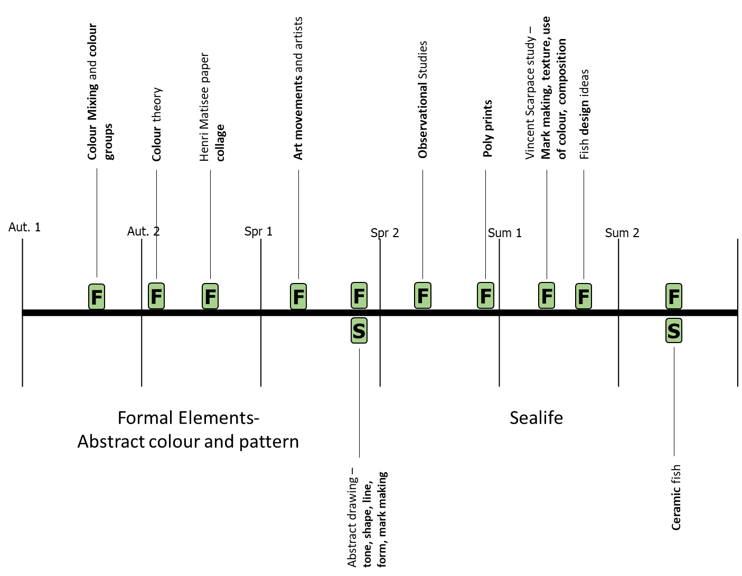
Year 7 Art and Design
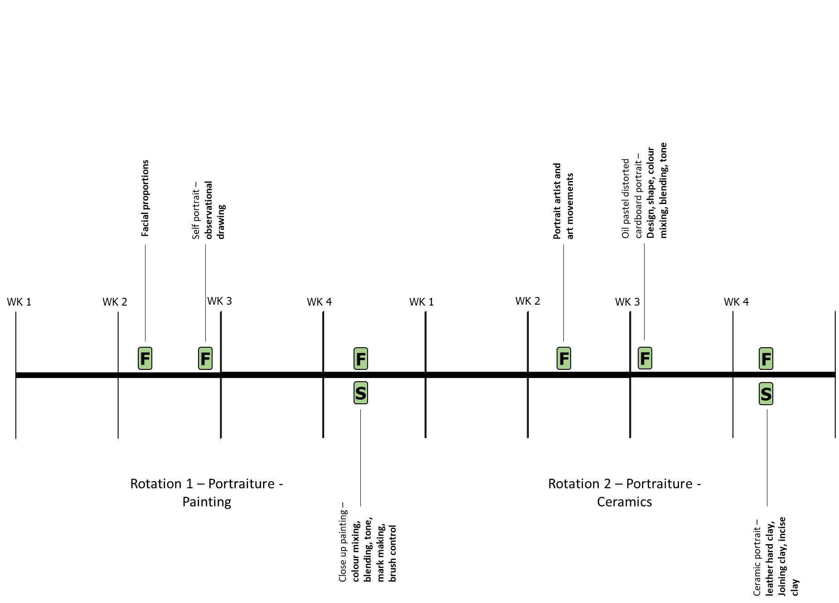
Year 8 Art and Design

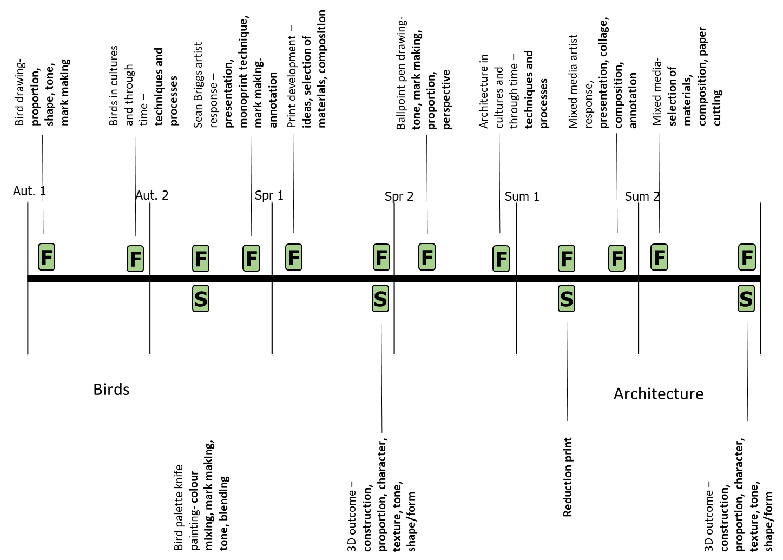
Year 9 Art and Design
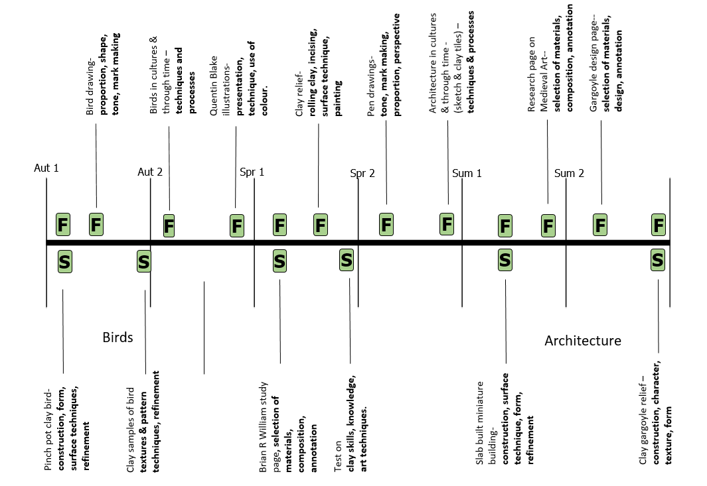
Year 9 Art (Ceramics)
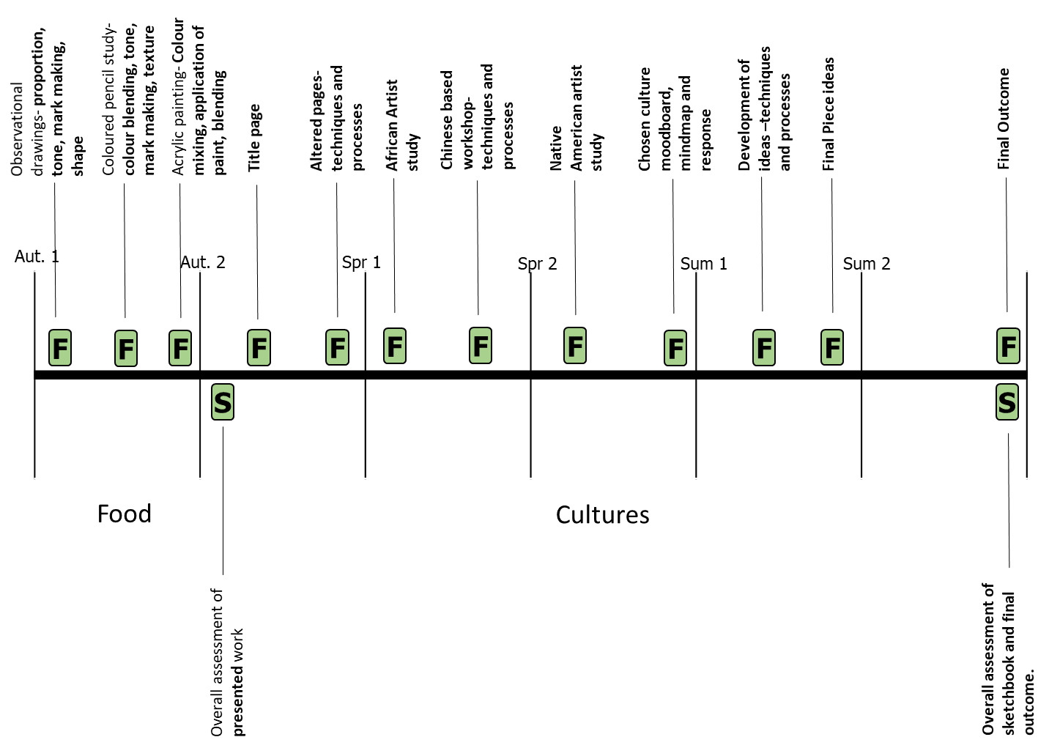
Year 10 GCSE Fine Art
Year 10 GCSE Art and Design (Three Dimensional Design)
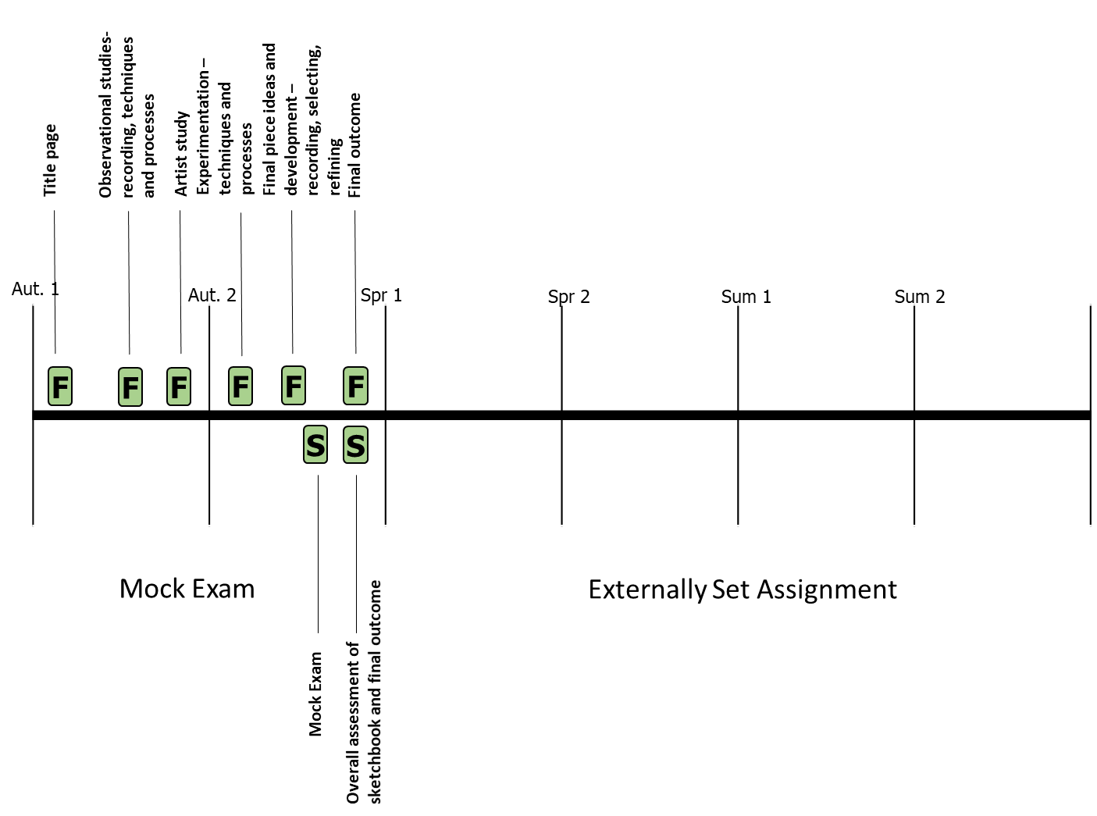
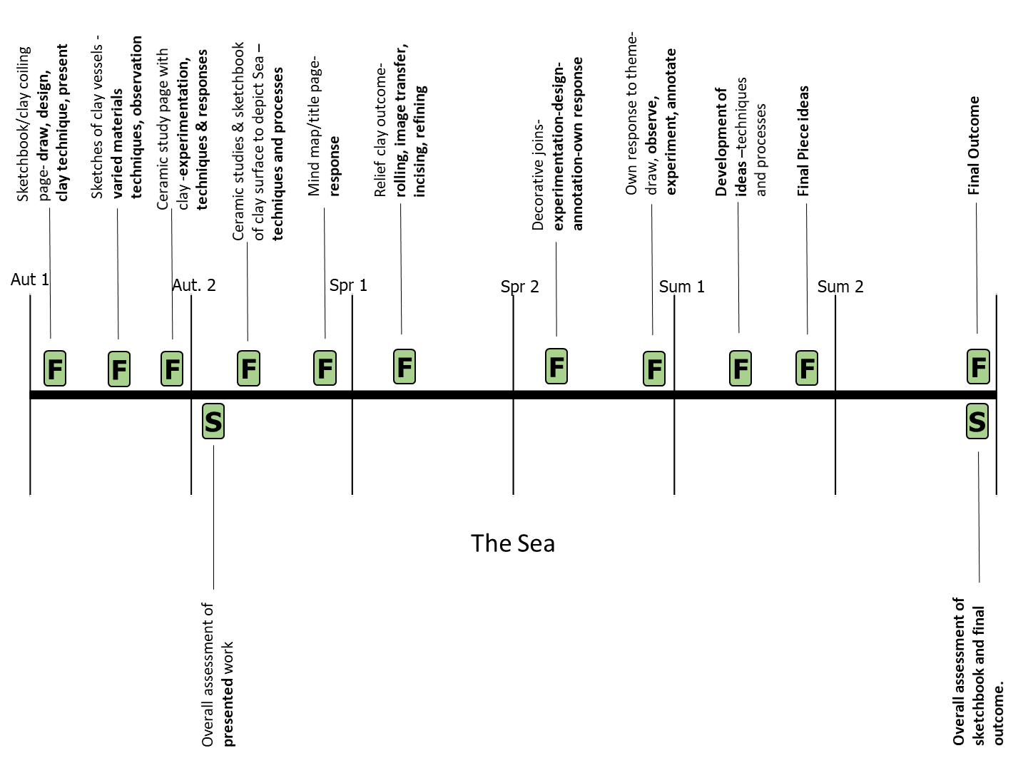
Year 11 GCSE Fine Art
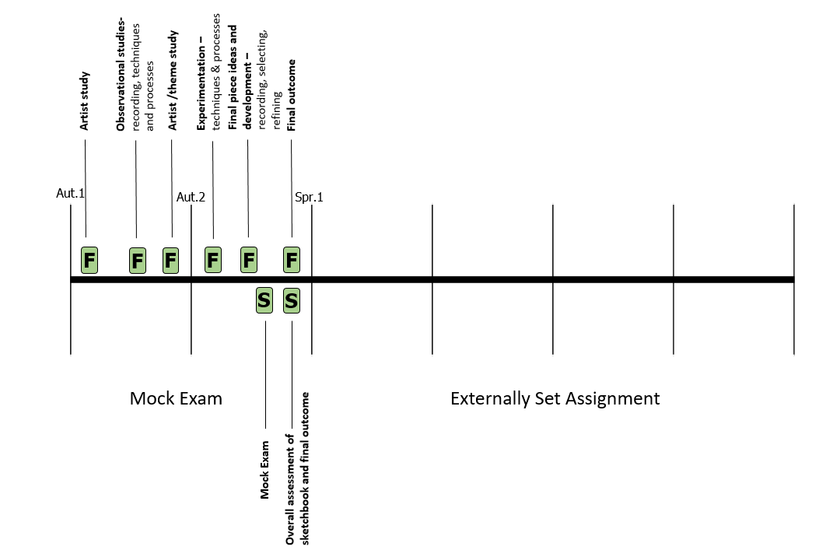
Year 11 GCSE Art & Design (Three Dimensional Design)
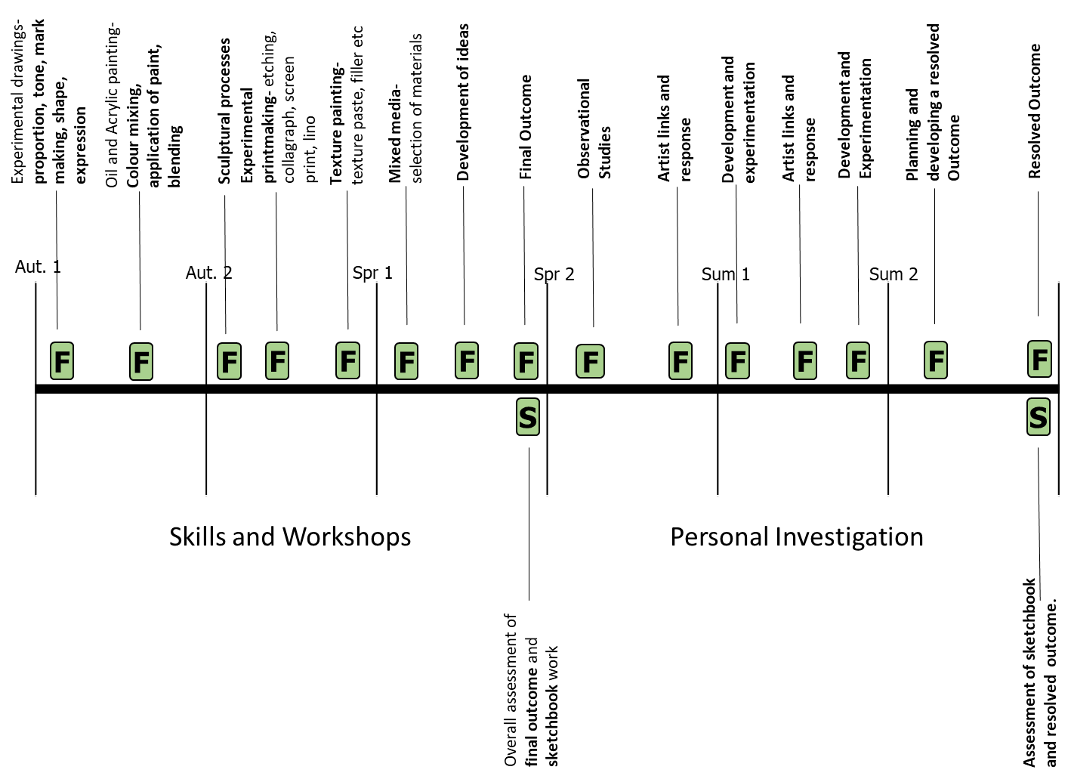
Year 12 A Level Fine Art
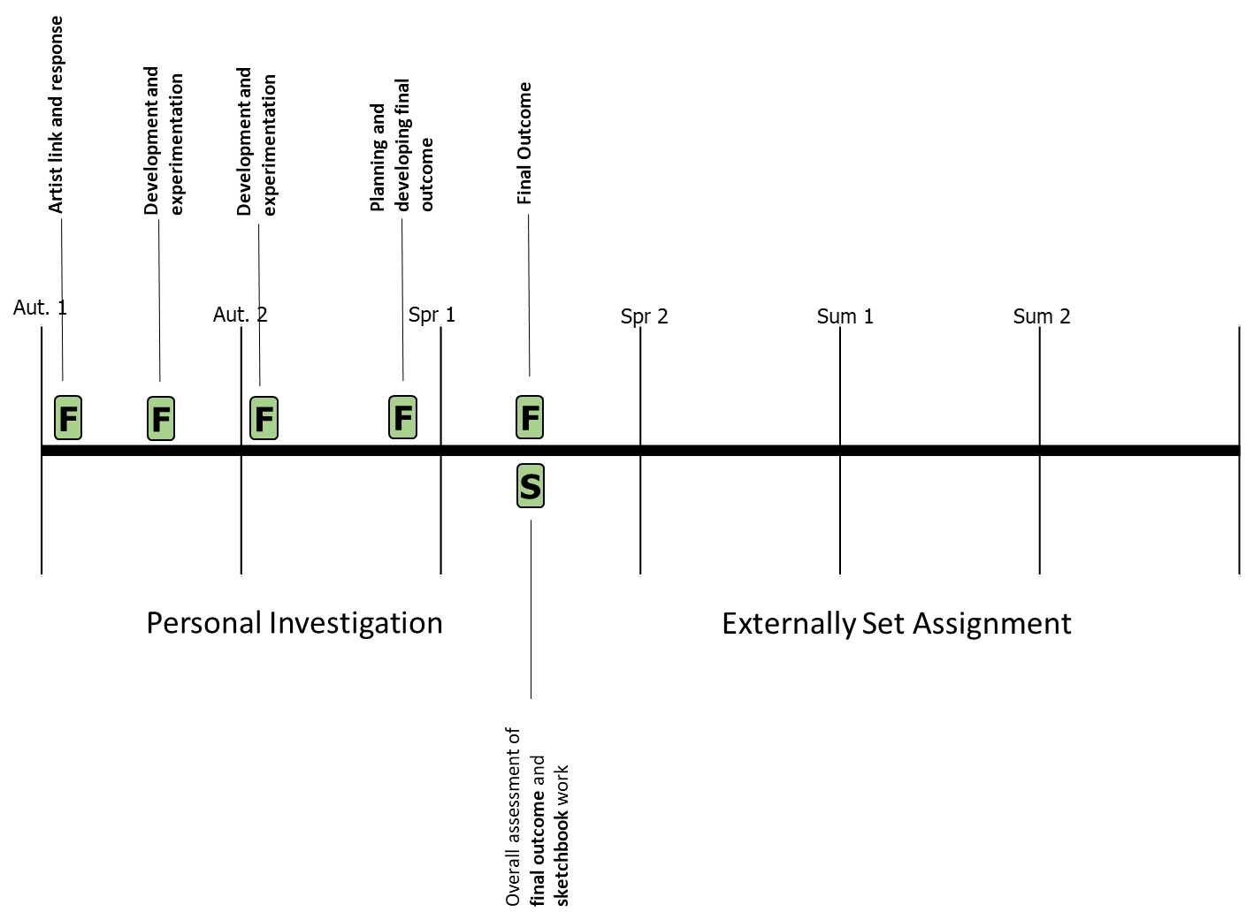
Year 13 A Level Fine Art

