Our Lady’s Catholic College

Assessment in the English Curriculum
Our Lady’s Catholic College, Morecambe road, Lancaster, La12rx

Rationale for Assessment

Formative Assessment
In English we understand that formative assessment is an integral part of delivering a responsive curriculum. Assessment is integrated throughout our curriculum and is used to assess how well the curriculum has been understood and remembered and to highlight misconceptions pupils may have developed in order to determine how to respond to the needs of the students in class.

At key moments within the sequence of learning, students complete a formative assessment, these will range from low stakes knowledge quizzes to longer writing pieces that assess how well each component has been understood and determines the misconceptions and areas of development that need to be addressed before they continue with the sequence of learning.
Each assessment is common across the department and all pupils sit the same assessment at the specified hinge point in the curriculum sequence. The expectation is that staff respond to the information provided by the MIGs via re-teaching or addressing misconceptions before they continue with the delivery of the planned curriculum sequence.

KS3 Assessment Model
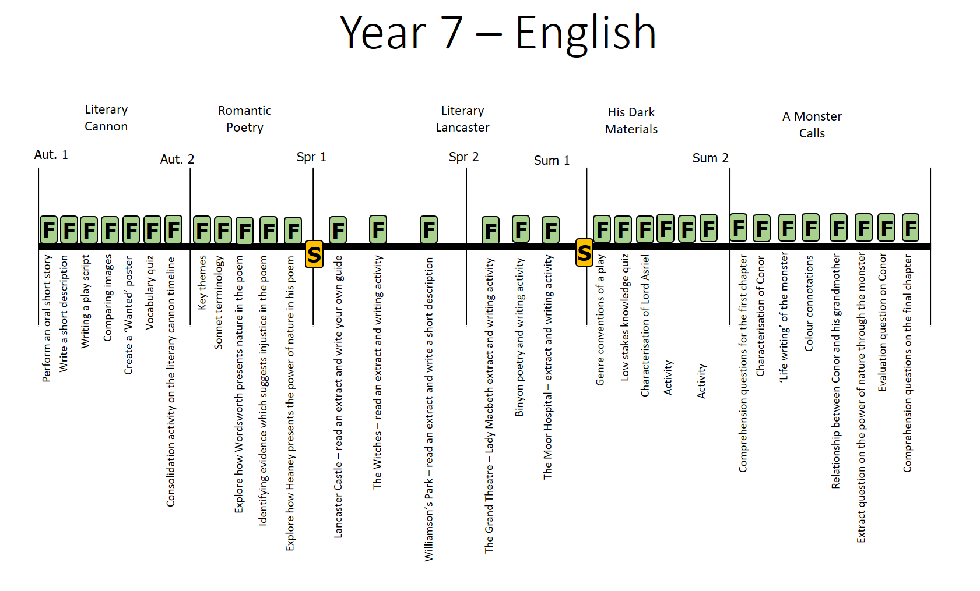
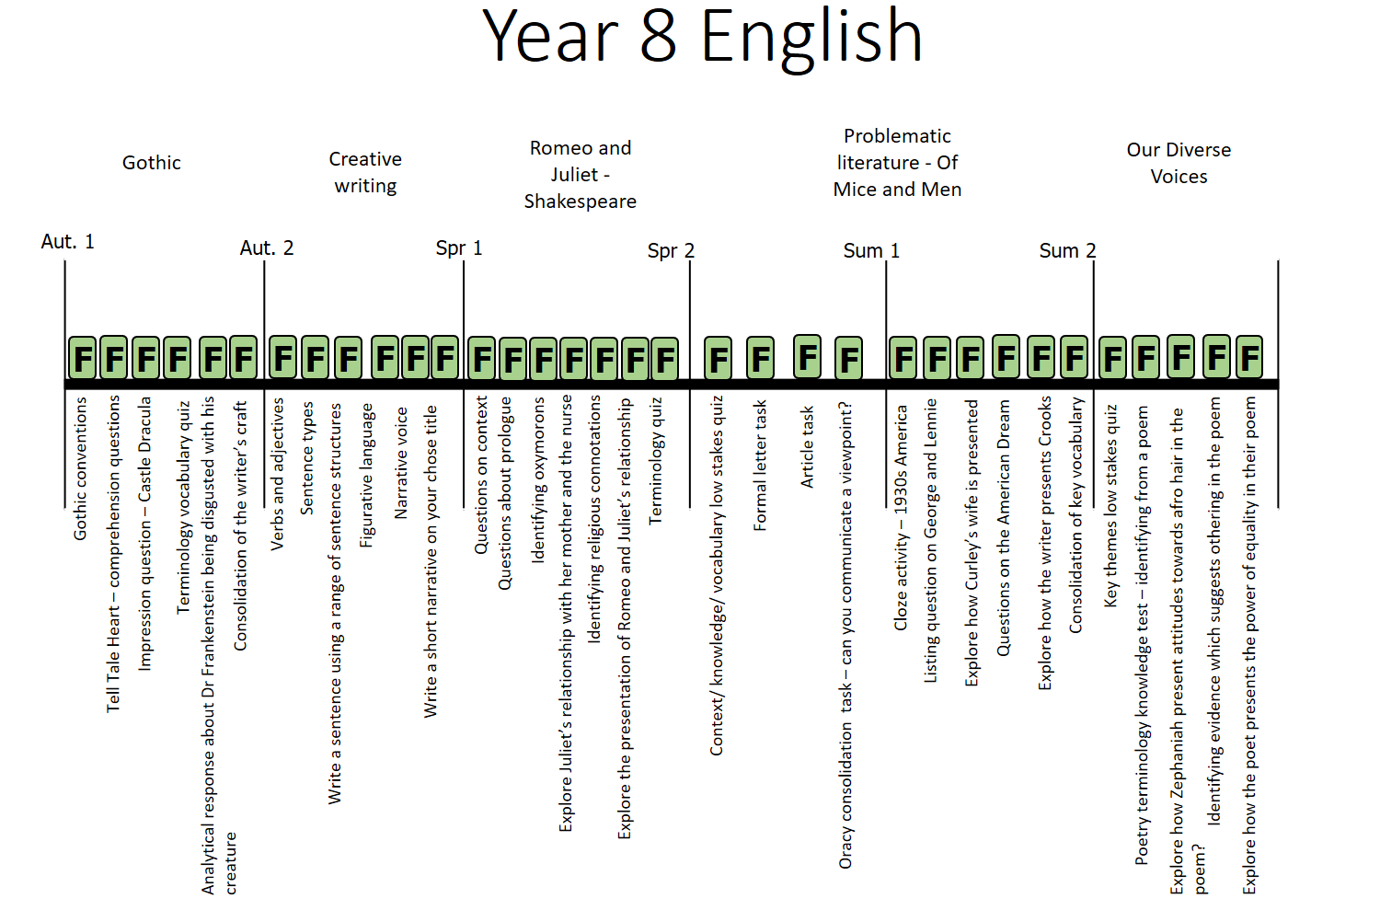

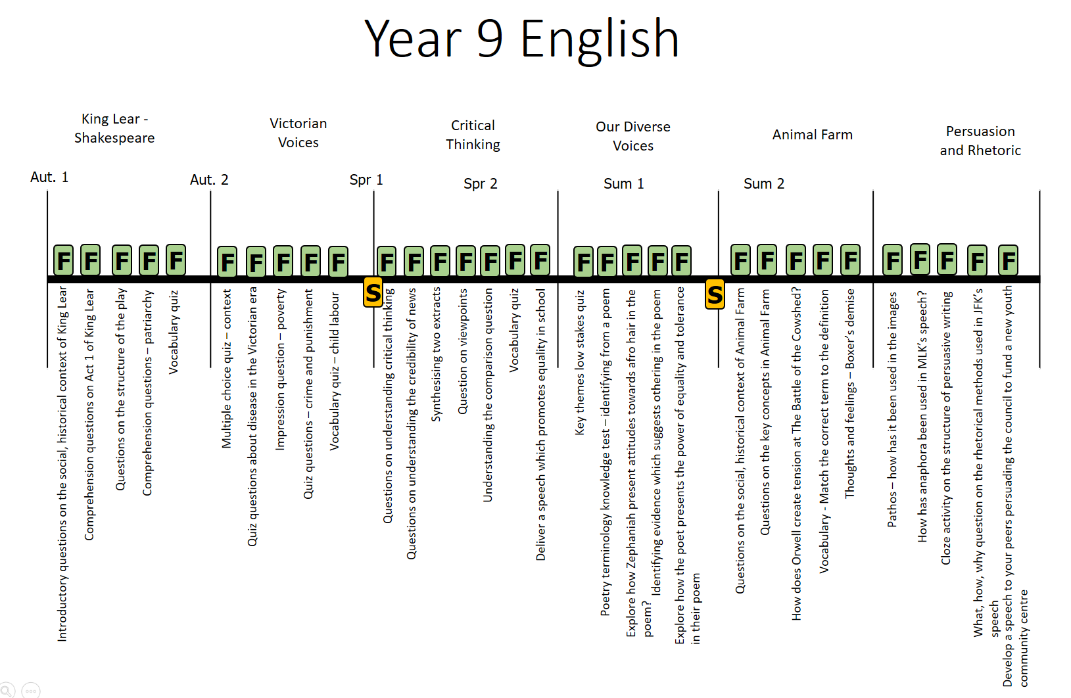
Synoptic Assessments

Our synoptic assessments are developed on the principle of desirable difficulties where prior learning is assessed in an unfamiliar context to ensure that there has been deep learning, not performance. The recall and retrieval questions aim to assess what pupils know and remember about the taught curriculum across key stage 3. Each synoptic is developed in a way that assesses the key component knowledge across all units of work and all year groups at KS3. We understand that it is important for pupils to build their schema of disciplinary knowledge and in particular their understanding of how to write in particular styles therefore, synoptic assessments also assess the students’ ability to answer English style questions eg. To evaluate and analyse as well as to write for the correct purpose and audience.

The synoptic assessments are cumulative and aim to give a clear picture of how well a student has understood the component knowledge addressed across the curriculum.

KS4 Assessment Model

At Key stage 4 we begin to prepare students for their external GCSE examinations. We do however understand the importance of ensuring that common formative assessments are carried out at specific hinge points in the sequence of learning in order to inform teaching and ensure that teachers can respond to misconceptions that arise before moving on with the planned sequence.

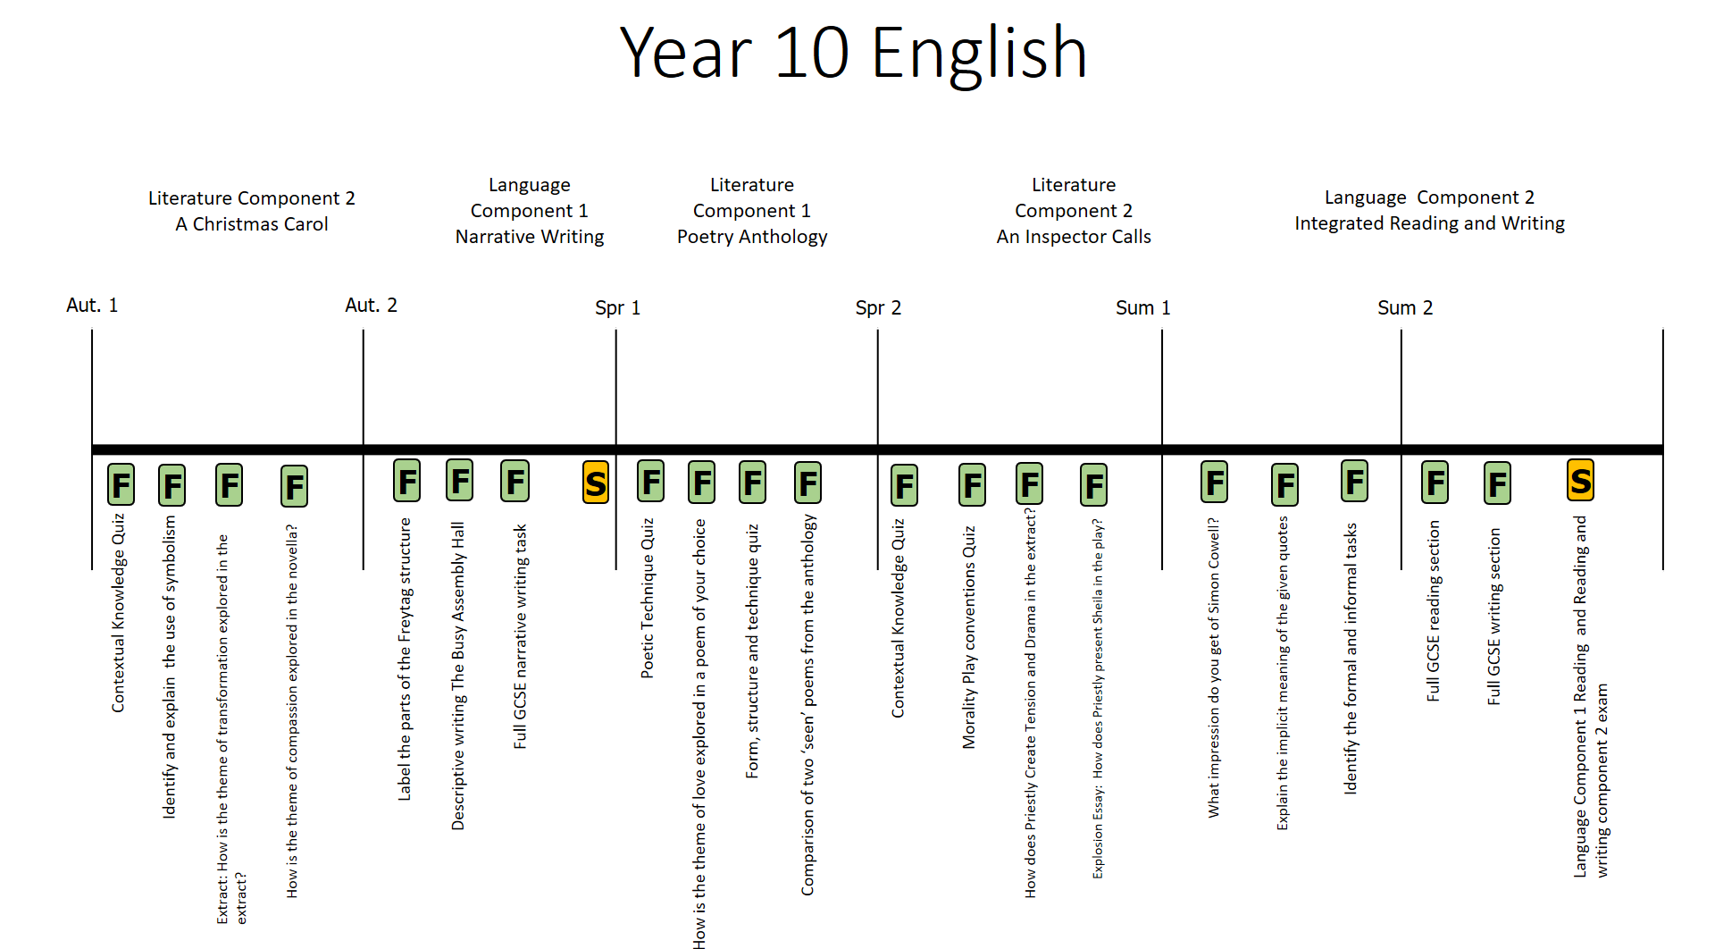

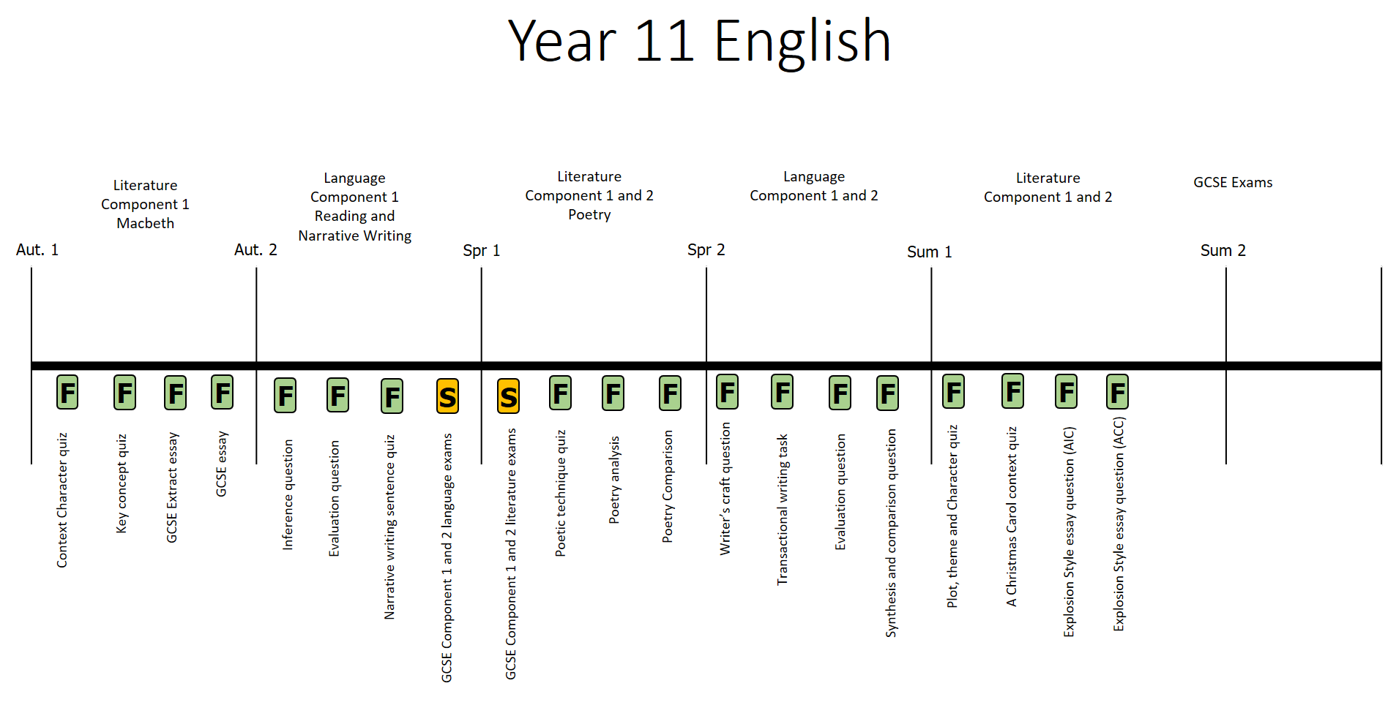

KS5 Assessment Model
At Key stage 5 we begin to prepare students for their AQA Language and Literature A-level examinations. Formative assessments are carried out at specific hinge points in the sequence of learning in order to inform teaching and ensure that teachers can respond to misconceptions that arise before moving on with the planned sequence.


