

**Some simple tips for using immersive reader in teams**

# Why is immersive reader useful for your child’s learning?

1. It allows your child to have all text documents read to them (so will help those who struggle to read)
2. It changes the colour of the background so that pupils with dyslexia can choose the best background colour for them
3. It identifies nouns, verbs, adverbs and adjective in a piece of work
4. It will break the words down into syllables to help with reading
5. You can increase in size of the text and the spacing between words
6. You can use a picture dictionary to help you child with word association
7. You can translate the text into a different language. Which will help if English is an additional language

**Where to find it in teams**

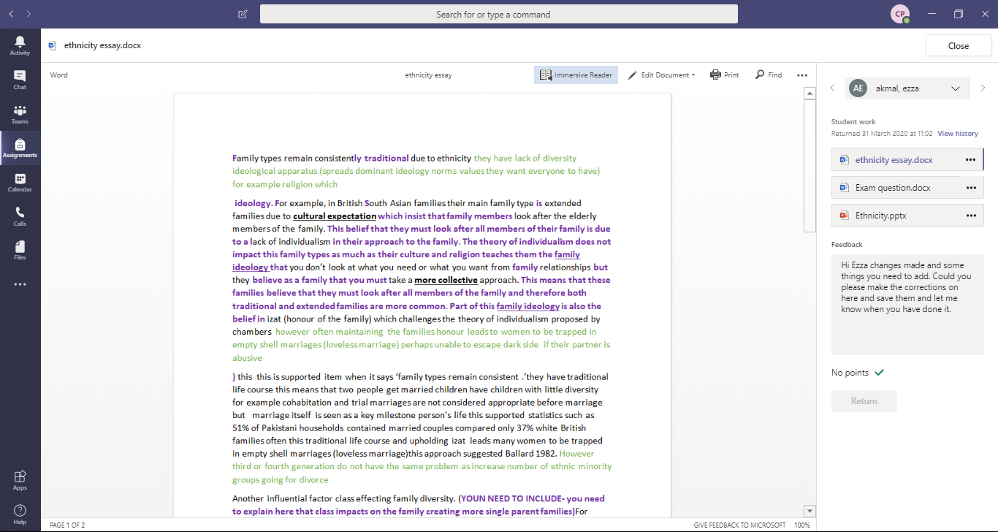

When you open a word document you will find it at the **top of a page here**

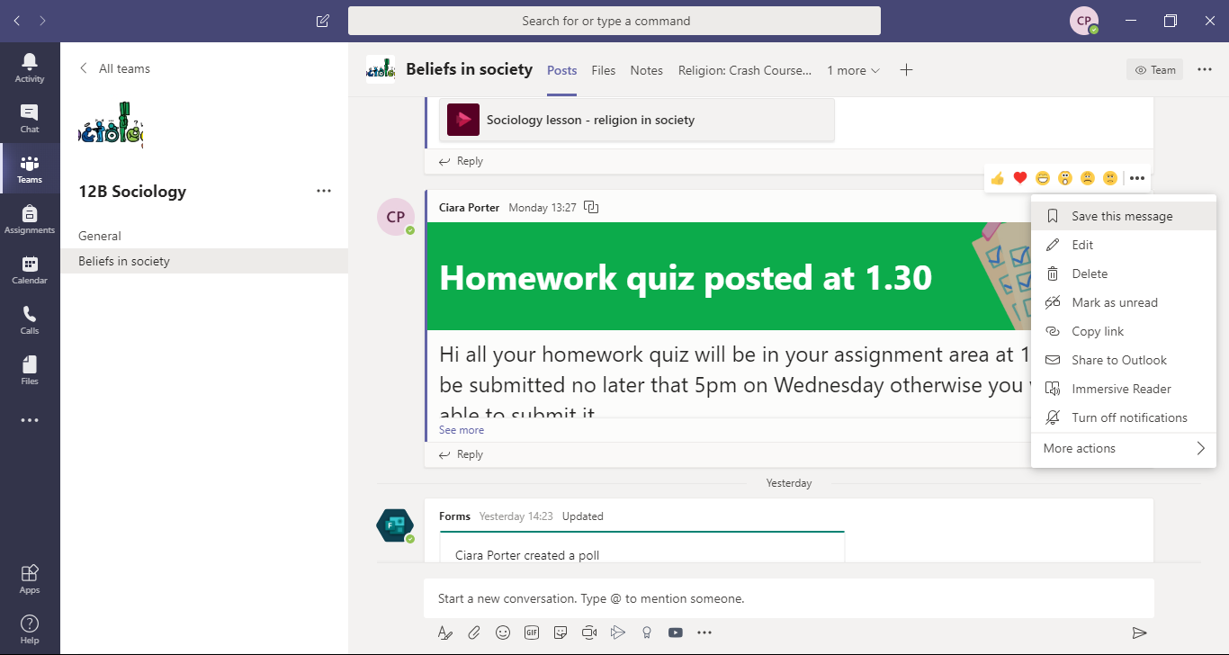

When you open notification or message on a teams page you will find it at the **top of the message. Click the three dots. It is the 2nd to last option in that menu.**

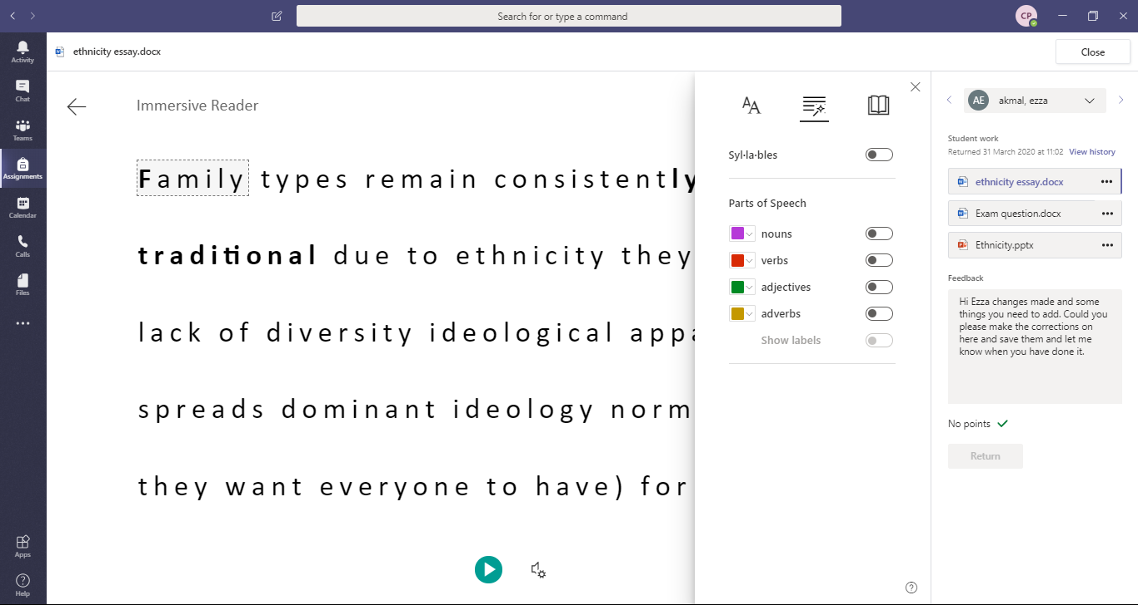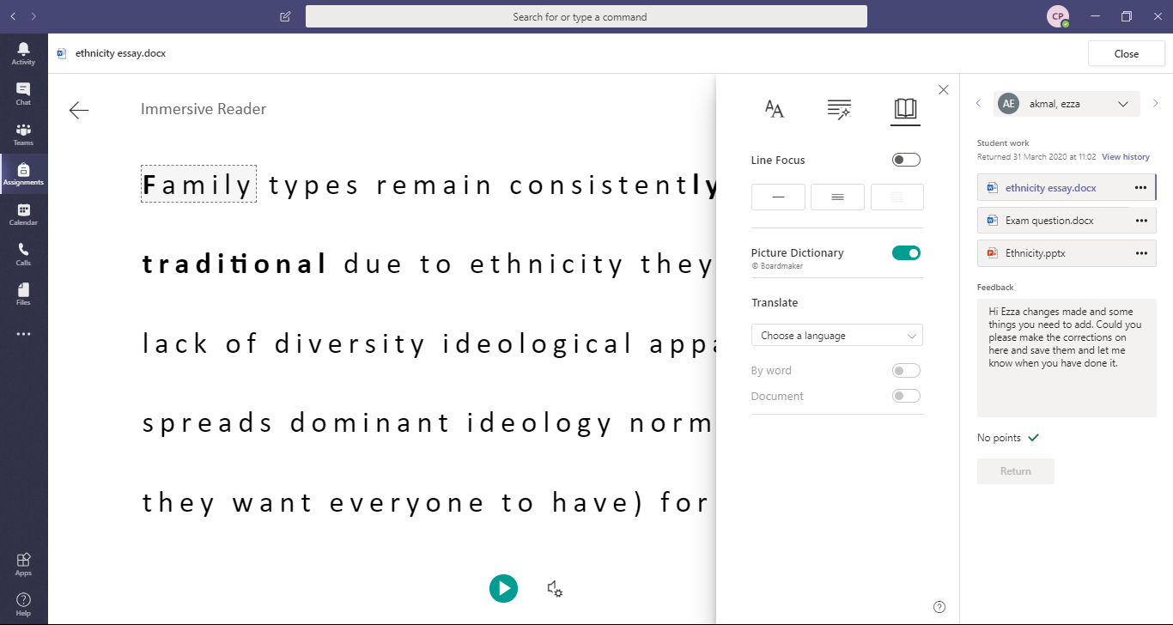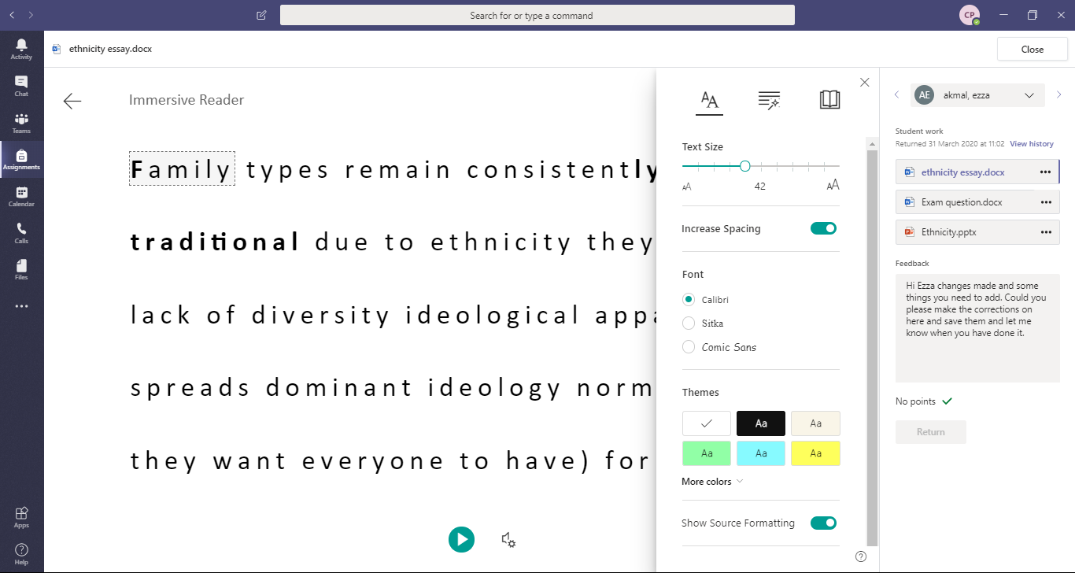

**EAL support**

1.It allows you to choose a text to translate the text into.

2.It also allows you to insert a picture to represent the word.

**SEN functions**

1. It changes the colour of the background which is useful for dyslexic pupils.
2. You can increase the size of the text.
3. You can increase the spacing between words.

**English**

It identifies nouns, verbs etc. in the text

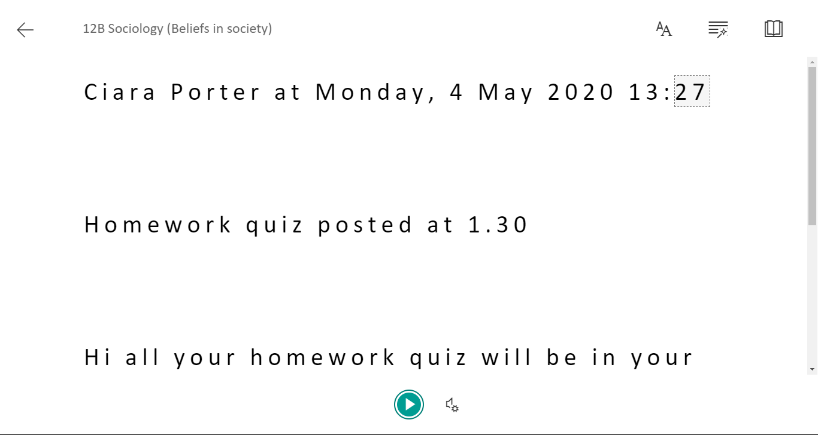

**What will I see when I open immersive reader?**

The following tabs will do the following:

Changing colour of the background and size of text **here**

Checking nouns and verbs **here**

Changing the language and using picture prompts **here**

You will see the text much larger and spaced press the **play** button to hear the text being read aloud



**This function**

* **Breaks the words into syllables to help with reading**
* **Identifies nouns, verbs etc**



**This function**

Changes the words in the following ways

* **Size**
* **The spacing between the words**
* **The colour of the background**





If you would like any additional information about immersive reader please use the link below.

**https://www.youtube.com/watch?v=sf5ypT9TpW4**

**This function**

* **Gives you a picture dictionary to help your child with word association**
* **Changes the language of the text to help children with English as an additional language**